Victorian Slalom Technical Committee – Version 2 2019

Role Descriptions – Officials Training

Contents
Race Registrar 2
Race Technical Director 3
Chief Judge 4
Race Director 5
Starter and Start Marshall (Pre Start Controller) 6
Finishers 7
Compilers 9
Gate Judges 10
Head of Safety 11
First Aider 11
Appendix – Basics of Judging 12

Race Registrar
The Registrar is responsible for coordinating publicity about the race, registrations and payments.

Key Responsibilities
The chief responsibilities of the Race Registrar are:
- Advertise the race on the Paddle VIC website and to Victorian clubs at least two weeks prior to the race day.
- Manage the race entry forms, updating the forms as required.
- Ensure all competitors registering for the event have fully completed the entry forms, including the appropriate declaration, so as to maximize the competitor’s insurance cover and to provide organisers with all relevant details and consents where applicable.
- If required, ensure that all competitors complete a confidential participant information form with any relevant medical and contact information.
- If required, ensure that all competitors have completed the code of conduct declaration
- At least three days before the race, download all the competitor registration information in the required format and forward to the Race Technical Director, or other committee member as delegated, to load into SiWi Data
- Download other information collected at registration, eg volunteer nominations, and forward to the Race Director before the race.

Interworking with other Roles
- The Race Registrar will pass all information about competitor registrations to the Race Technical Director.
- The Race Registrar will pass all other information collected at registration, eg volunteer nominations, and forward them to the Race Director before the race.

Race Technical Director
The Race Technical Director is responsible for ensuring that all technical equipment required by officials for running the race is available and working. Key responsibilities of the Race Technical Director are:

Key Responsibilities
Before the race day
- Register the race in SiWi Data.
- Load the competitor information into SiWi Data.
- Set up the race schedule in SiWi Data.
- Print three copies of the start lists to be given to Start, Finish and Compiling. (The copy for Compiling will also be used when handing out bibs).
On race day
- Ensure that power is provided for all equipment.
- Ensure that the start and finish beams and timing equipment are installed and tested.
- Ensure that the compiling equipment is set up and tested.
- Ensure that the communications equipment with start, finish, Chief Judge and gate judges are set up and working correctly.
- Ensure there is a working printer and supplies available for posting results during the race
- Provide technical support to the above equipment during the day.
- Oversee dismantling and pack up of the above equipment at the end of the race.

Interworking with other roles
- The Race Technical Director works closely to support all other race officials.
- The Race Technical Director will inform the Race Director on race day when all technical equipment is working and tested and from a technical point of view the race is ready to start.
- The Race Technical Director will inform the Chief Judge if there is a technical issue which may require a delay to be called in the race schedule.

Equipment
- Generator
- Start/Finish beams and cabling to connect to compiling equipment
- Radio or headset equipment for communication with start, finish, chief judge and all gate judges
- Compiling computer(s) and printer(s)
- iPads for each judging sector
- WiFi for communication with the iPads
- Display stand for results

Chief Judge
The Chief Judge has the final responsibility for all race results.

Key Responsibilities
- To ensure the course is designed and set appropriate to the standard of the event
- Provide the initial briefing to competitors (may be delegated to the Race Director)
- Provide the initial briefing to judges and assign judges to the gates
- Review Unofficial Results from each class in SiWi Data and post Unofficial Results for competitor viewing
- Manage and make the final decision on all race enquiries
- Determine when Unofficial Results should be made Official and post Official Results for competitor viewing
- Make all decisions to start, stop and resume racing in response to natural events, eg lightning; on course events, eg of a safety nature; or technical events, eg changes in river level, or technical problems in compiling.
- Makes all decisions regarding course changes during a race, eg raising or lowering gates as river levels change.
- Signs off final race results and placings before presentations are made.

Key Responsibilities

Interworking with other roles
- Oversee the competence and placement of gate judges
- Liaise with gate judges as required to determine the results of an official enquiry
- Liaise with the Race Director regarding the race organisation and inform the Race Director when all judges are in place and ready to start the race
- Liaise with the Race Technical Director regarding any technical problems in race timing and compiling during the race.
- Confirms final race results to the Race Director.

Equipment
- Radio or headset equipment for communication with start/finish/compiling and with gates judges
- Mobile phone

Race Director
The Race Director runs the logistical side of the race and is responsible for communication with competitors. The Race Director is also responsible for the comfort and safety of race officials and overseeing overall race safety.
(For Yarra Series races the Race Director can also act as the general race liaison for new competitors, family and friends and will wear a yellow vest to denote this role – or delegate this role to someone else)

Key Responsibilities
- Before and during the race liaise with the Head of Safety to ensure that the course is safe for paddling. Ensure the correct safety is provided for the conduct of the event.
- Take all steps required to minimize exposure to risk to competitors, officials, spectators and the general public.
- Provide the competitor briefing (if delegated by the Chief Judge)
- Liaise with the Race Technical Director and Chief Judge to determine when the race is ready to start (all officials are in place).
- Provide announcements during the day to keep competitors and officials informed of the race progress, eg calling up the next class to compete, announcing breaks, etc.
- For Yarra Series – During the race, audit check lists against manual times from finish, and handle enquiries and appeals.
- Present or organise for presentation of awards and trophies.

Interworking with other roles
- Race Technical Director
- Chief Judge

Equipment
- Radio or headset equipment for communication with Race Technical Director and Chief Judge

Starter and Start Marshall (Pre Start Controller)

Key Responsibilities
The start line is usually manned by a Start Marshall and Starter who together have the responsibility to:
- Find out the number of gates covered by Judging Section 1 to ensure that no two athletes are paddling in this section at the same time.
- Marshall athletes onto the course into the starting area
- Check that athletes are present according to the Start List
- Check that each athlete has the correct equipment and is wearing safety equipment (PFD, helmet) correctly. Eg air bags are present where required, helmet is done up, etc.
- Ensure that all paddlers wear approved safety equipment as per ICF Rules 2017.
- Ensure that all watercraft and paddling equipment meet appropriate safety standards and competition specifications.
- Provide a warning to athletes intending to start with incorrect equipment, eg helmet undone.
- Coordinate the start with Compling:
  - Advise Compiling of the next athletes/bib numbers queued to start
    - start athletes in bib order only for major events
    - start athletes in bib order where possible for Yarra Series.
    - Compiling will advise of athletes approved to do first and second runs during the first run session
    - For Yarra Series events, C2 boats can be slotted in when appropriate to allow for boat sharing
  - Advise Compiling of any athletes not starting according to the Start List (DNS: Did not show)
  - Do Not vary the start order advised to Compiling without confirmation from Compiling
  - Advise Compiling when each athlete starts, via a count-down (“Bib xx starting in 3, 2, 1”), and hold the radio in such a way that the beep from the athlete breaking the start beam can be clearly heard over the radio.
  - For events where a clock is not provided, start athletes no less than 1 minute apart
- Ensure that there are no more than three athletes on the course at any one time (this is the number of clocks held at the finish line). Particular care should be taken not to start another athlete too soon after an overtake.
- Where possible, coordinate start with Finish, ie, avoid starting an athlete when a paddler on the course is about to cross the finish line. This will be advised by the finishers over the radio (“Bib x approaching finish / Bib x finished)
- Maintain effective communication with Compiling and Finish at all times. (When using radios instead of headsets, only one person can talk/be heard at a time, therefore Start/Finish/Compiling need to be careful not to talk over each other).

Interworking with other roles
- The Starter and Start receives the Start List from Compiling and will start athletes according to the Start List only.
- The responsibility and authority to make decisions to alter the race schedule is the responsibility of the Chief Judge only. The Start Marshall will receive notification from the Chief Judge only of when to vary the race for, for example:
  - Capsize causing delay
  - Overtake causing lack of available clocks / delay
  - Approval to run boats out of race order
  - Lightning or other natural event
  - Technical issues holding up the race

Equipment
- Start List
- Radio or headset equipment for communication

Finishers

Key Responsibilities
The finish line is usually manned by two finishers. One finisher is the recorder who starts and stops the clocks and records times. If possible, the recorder sits in a position such that they look directly across the finish line (lined up with the finish beam) to make sure the finish time is accurate.
The second finisher manages communications over the radio/headset. If using a ratio, it is important to keep the radio some distance from the clocks as the radio can cause interference from the clocks, but to be close enough so that the record keeper can hear the start beep over the radio.
The finishers have the responsibility to:
- Record the next athlete to start their run on the Finisher’s Record Sheet as advised by Start over the radio/headset (record keeper)
- Start one of the three ‘clocks’ each time an athlete starts a run. This is alerted by the count-down from the Starter and the clock is started when the beep from the start beam being broken is heard over the radio/headset (record keeper)
- Advise Compiling / Start when an athlete is coming to finish / finishing (“Bib x approaching finish / Bib x finished)
- Stop the relevant clock when an athlete’s body crosses the finish line.
- Record the ‘raw’ finish time on the Finish Record Sheet and if time permits, record the time converted to hundreds of seconds on the same sheet.
- Advise Compiling if a manual time is not captured. This can happen for a number of reasons including: more than three athletes allowed onto the course; stopping the wrong clock; missing the start beep over the radio/headset, etc.
- Advise Compiling of a manual time if requested.
- Keep the finish records in good order – number/date sheets, sign finish sheets as required.
- Maintain effective communication with Compiling and Start at all times. (When using radios instead of headsets, only one person can talk/be heard at a time, therefore Start/Finish/Compiling need to be careful not to talk over each other).
- Advise Compiling at all times of any issues at the finish line, eg a false trigger of the finish beam caused by an athlete who has finished paddling upriver and breaking the beam again.
- In the case of a teams event, the finish record keeper will also determine if the first/last boat of the team finish within 15 seconds of each other and advise Compiling if this is not achieved as a penalty will apply. (Usually there are not three teams on the course at a time and there is a spare clock available to time this gap)
The finish team will also at times:
- Ask experienced athletes to stay on the water after completing a race to ensure that at least three competent athletes are available below finish to act as safety
- Ensure that athletes who have completed their run and remain on the water do not paddle up through the finish beam again and provide a false trigger.

Interworking with other roles
- The Chief Judge will advise of any changes to the race order/schedule
- The Race Director will advise of any changes to the race logistics

Equipment
- Start List
- Finishers record sheet
- Timing clocks and equipment
- Radio or headset equipment for communication

Compilers
The Compilers have the responsibility of capturing and logging all athletes’ race times.

Key Responsibilities
- Hand out bibs to registered athletes and take details of non-registered athletes
- Make any adjustments to the start list as required
- Inform Start and Finish of any special requirements that impact that start order, eg athletes approved to do two runs in the first session, etc.
- Before the start, make sure all judging stations are online and inform the Race Technical Director when the race is ready to start from the Compilers point of view
- Record the next bibs that will race as advised by Start and enter each paddler into the race system when they are about to start and the correct bib is queued next to the start clock.
- Ensure that the finish clock is queued next to the correct paddler about to finish as advised by the Finish team over the radio/headset. This includes managing overtakes.
- Record a capsize
- Once a paddler has finished a run, review the race time to make sure it is reasonable. Recover the correct timing impulse as required (see advanced training)
- Print check lists progressively so paddlers can check their times – normally every 5 paddlers.
- Second compiler:
  - Check that all penalties are coming in from the judging stations (may be done on a second computer). If not, get the penalties from the relevant judge over the radio/headset or from the judging sheets and enter the results manually
  - When all penalties are in for a paddler, tick 'OK' which will clear the paddler from the judges IPAD screen and the compiler active race windows
  - When a change of penalties comes in from a gate judge or the chief judge change the penalty in the race (ensure the status is In Progress)
- For each class
  - When the first paddler in the class starts - change the status to 'In Progress'
  - Record a DNS if a registered paddler does not race in the class.
  - When the last paddler in the class has raced – change the status to ‘Unofficial’, print the class results, add the results for any 'unassigned' paddlers who may be in that class and give the results to the Chief Judge to review and post
  - When the chief judge advises that the results can become official, change the status to ‘Official’, print out the final results, add the results for any ‘unassigned’ paddlers who may be in that class and give the results to the Chief Judge to review and post.
- Compiling will manage start/finish so that in SIWI there is only one competitor queued to start, with the start clock against their bib, and one competitor with the finish clock against their bib at any one time

Interworking with other roles
- The Compilers work closely with Start / Finish and the Race Technical Director

Equipment:
- Start list, scrap paper, pens
- Computer and equipment for compiling
- Radio or headset equipment for communication
- Mobile Phone

Gate Judges
Gate Judges determine the penalties to be given to paddlers for touching or missing gates; and manage paddlers to prevent them from interfering with each other. Note, Judges. Gate judges will work on judging stations in pairs or threes and be assigned up to 6 gates to review. Two judging stations may be given the same gate to judge (eg judging station 1 may judge gates 1-5 and judging station 2 may judge gates 5-9) . One judge will be the primary gate judge for any given gate. Each judging station will also assign a ‘transmission judge’ who is responsible for recording penalties on the iPad (if using) and communicating any penalties not correctly received by Compiling over the radio/headset. Please see Appendix 2 for how to refresh an iPad.

Key Responsibilities
- Determine, according to the ICF rules, whether a competitor has incurred a gate penalty (touch / miss). See separate Appendix.
- Clearly mark judging sheets with judge’s name, sheet number, bib number of competitor and penalties.
- Prevent slower paddlers from interfering with faster paddlers by ordering slower paddlers to interrupt their paddling to let the faster paddler through (whistle signal)
- The Primary Judge will record the penalty against the bib and gate numbers on the Judging sheet, with notes regarding what was observed and why the penalty was given if required or the penalty is likely to be queried.
- The Transmission Judge will record the penalty awarded by the Primary Judge on the iPad.
- The Transmission Judge will communicate with Compiling to clarify any penalties recorded or any penalties that have not transmitted correctly to compiling.
- The Transmission Judge will refresh the iPad where required, for example if communication with compiling is lost – see Appendix 2 for process.
- The Transmission Judge will report an overtake or capsize over the radio / headset if it happens in your judging section.
If there is any doubt about a penalty, call for the chief judge to confirm and notify compiling that the penalties are being reviewed.
If compiling calls in asking for penalties to be radioed through, and the section is busy, notify compiling so they do not keep calling, and call back when not busy.

Equipment
- Start List
- Judging sheets
- Pens
- Radio or headset equipment for communication
- iPad

Head of Safety

Key Responsibilities
- Ensures all safety issues of the course have been identified and mitigated
- Organize and brief all safety personnel on positions, risk management and emergency response plans and expectations.
- Provide briefing material to race organizer to inform paddlers and participants on any safety issues.
- Check, on all environment hazards [such as weather, river levels, water quality etc.] and report situation and recommendation to Race Organizer and Event Organizer
- Check, or water hazards and report on issues to Race Organizer and Course Designer
- Ensure communication plan is updated and distributed accordingly
- Ensure all communication channels are available and in place [such as radios or headsets and mobile phones]
- Ensure all safety equipment is available and in working order for Rescue teams
- Maintain the site to an appropriate standard so as to minimize risks of competitors, officials, spectators and the public.
- Provide an adequate First Aid Kit and place this in an appropriate location that is known.
- Ensure suitably qualified persons are tasked to the duty of First Aider and provide suitable workplaces for that duty.
- Provide throw bags at appropriate locations along the slalom course and to ensure that persons at the stations have adequate training in the use thereof.
- Provide appropriately qualified on- water safety personnel during the competition.
- Provide emergency access to a working telephone. This may be either a land line or mobile provided there is suitable signal and reception to enable a call to be made at any time.

Equipment
- Emergency contact list
- Evacuation and checkpoint information (maps]
- Incident report sheets
- Communication equipment

Interworking with other roles
Member Protection Officer…

First Aider
A suitably qualified First Aider nominated by the head of Safety.
(etc)

Equipment
- First Aid Kit
- Incident report sheets
- First Aid report forms
- Communications equipment
- Communication plan
- Emergency Contact List
- Medical Forms (or access to)
- Emergency Response Plan

Appendix 1 – Basics of Judging
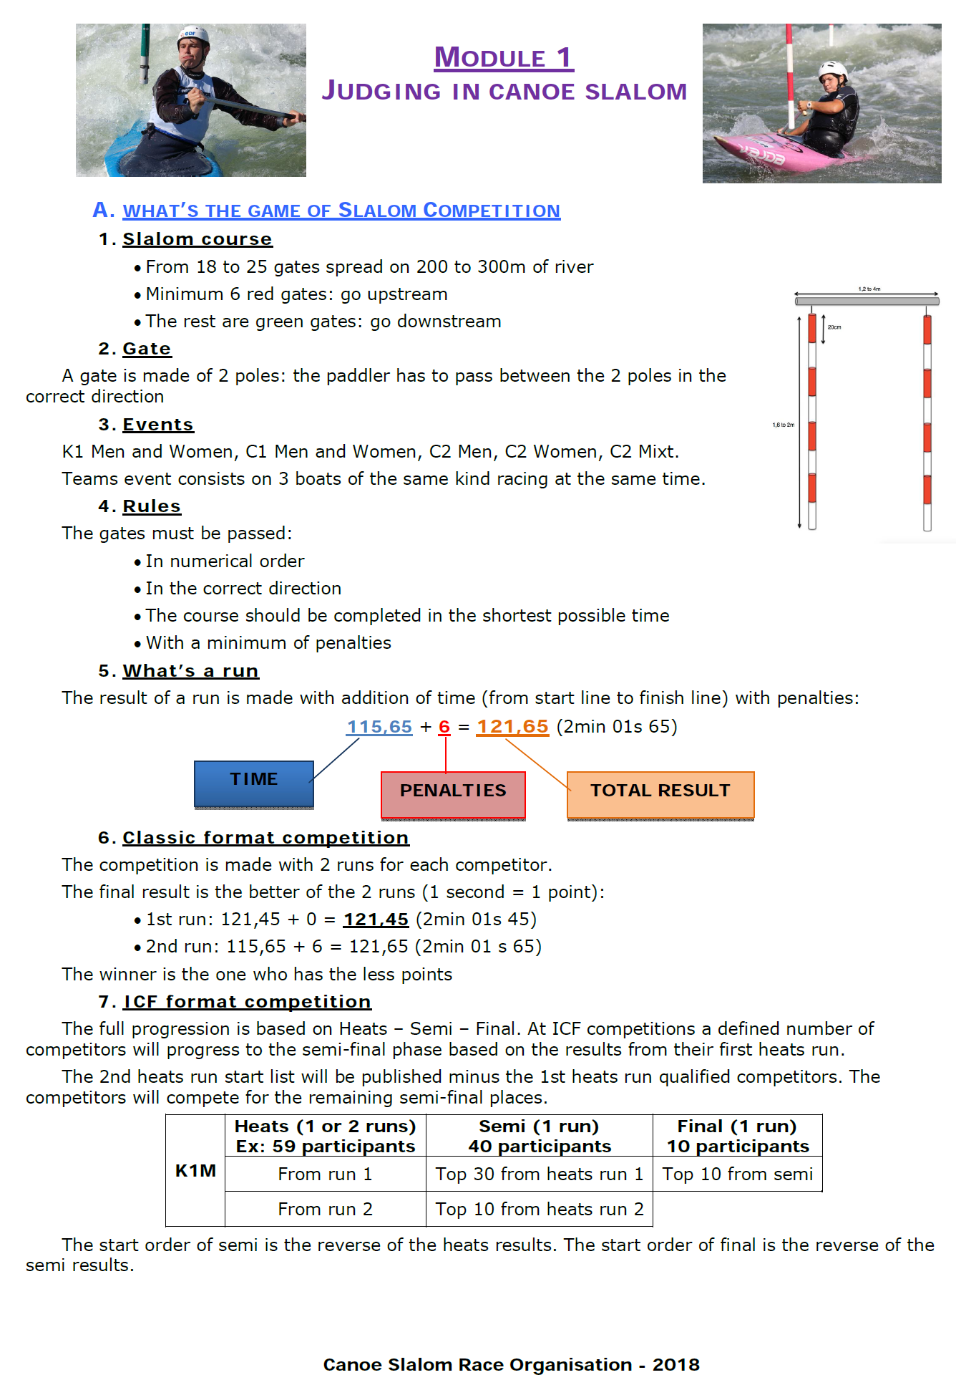

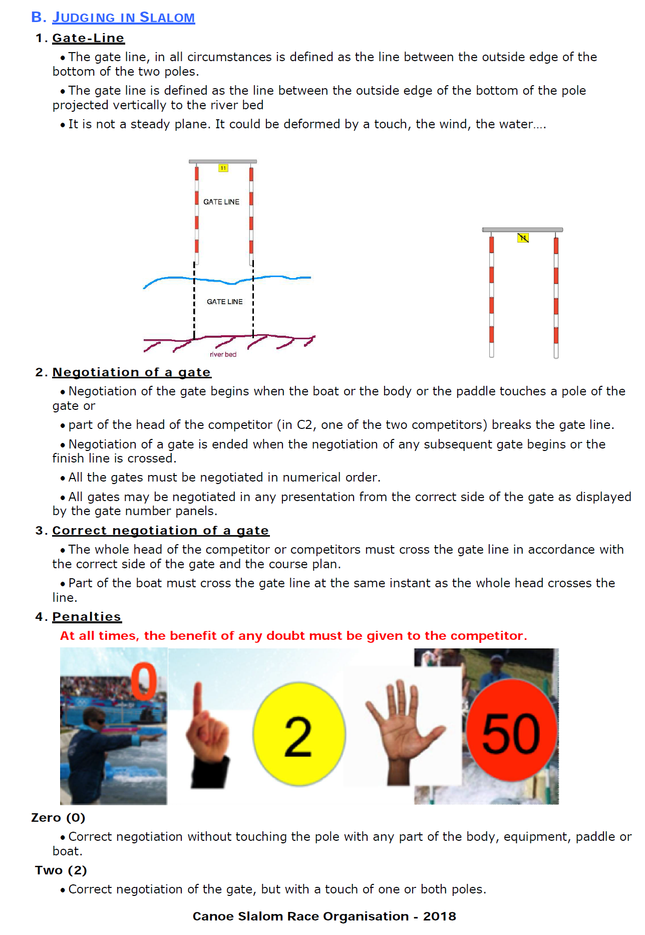

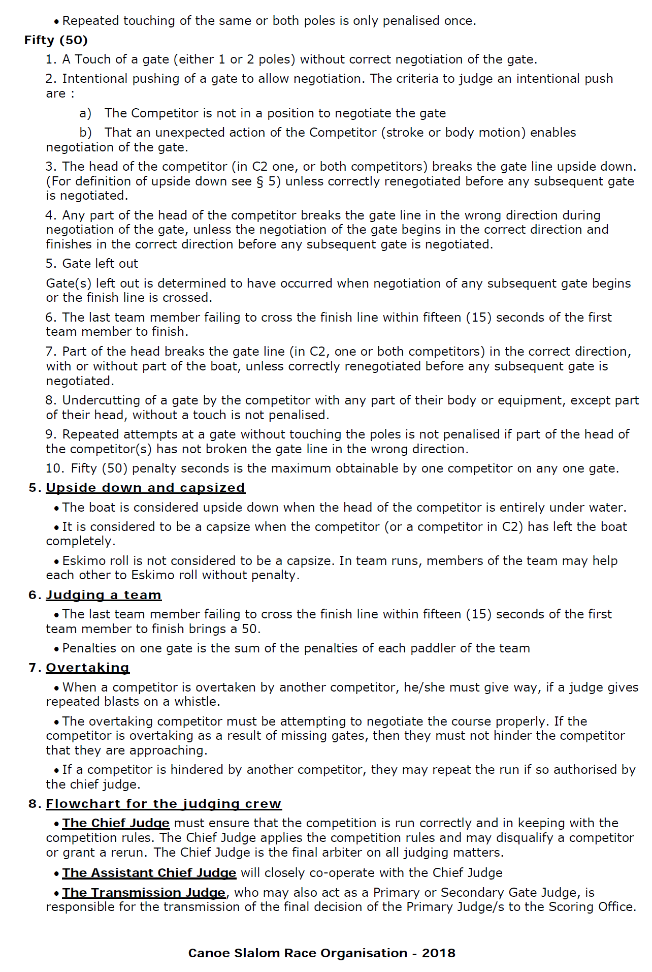

Appendix 2 – How to refresh Judging iPad

If a Judge’s iPad loses communication with Compiling it may need to be refreshed using the following procedure:
- Use the Refresh symbol ( at the left hand side of the url)

- Press Sectors (gear wheel top left)
- Press Home (house symbol top left)
- Select ‘Choose Judging Sector’

- Pick your sector
