

Victorian Canoe Association Inc.
Annual Report
2018-2019
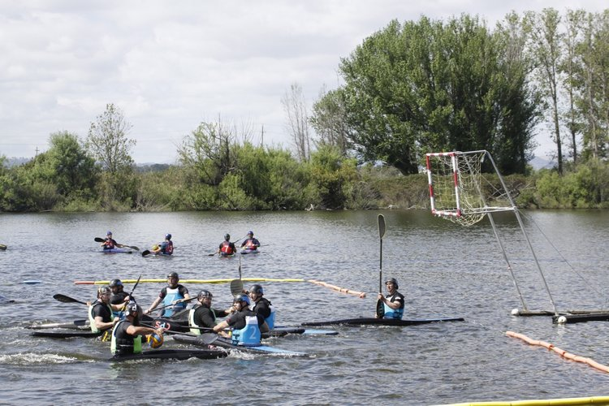
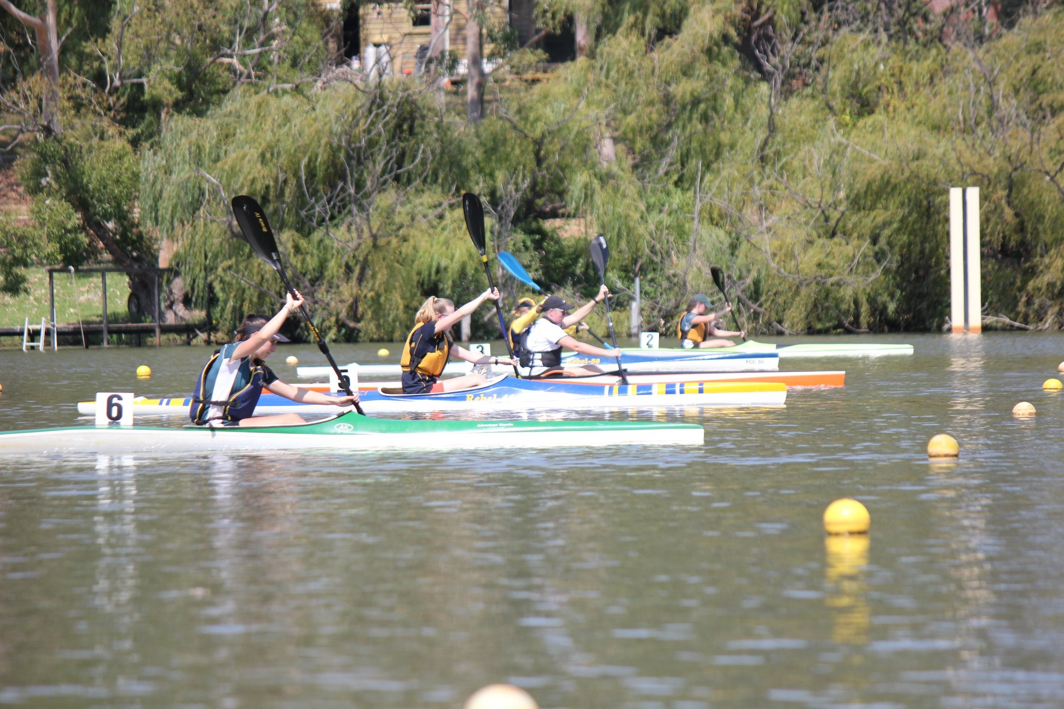

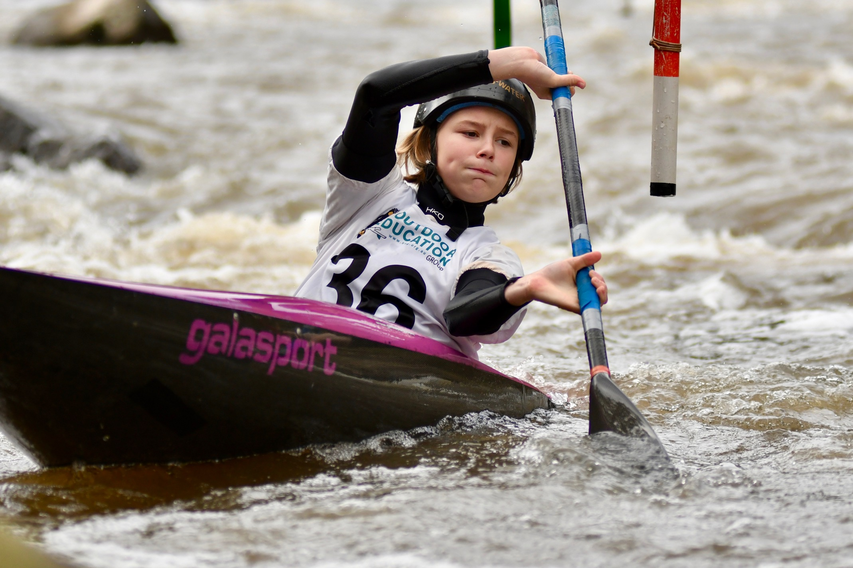
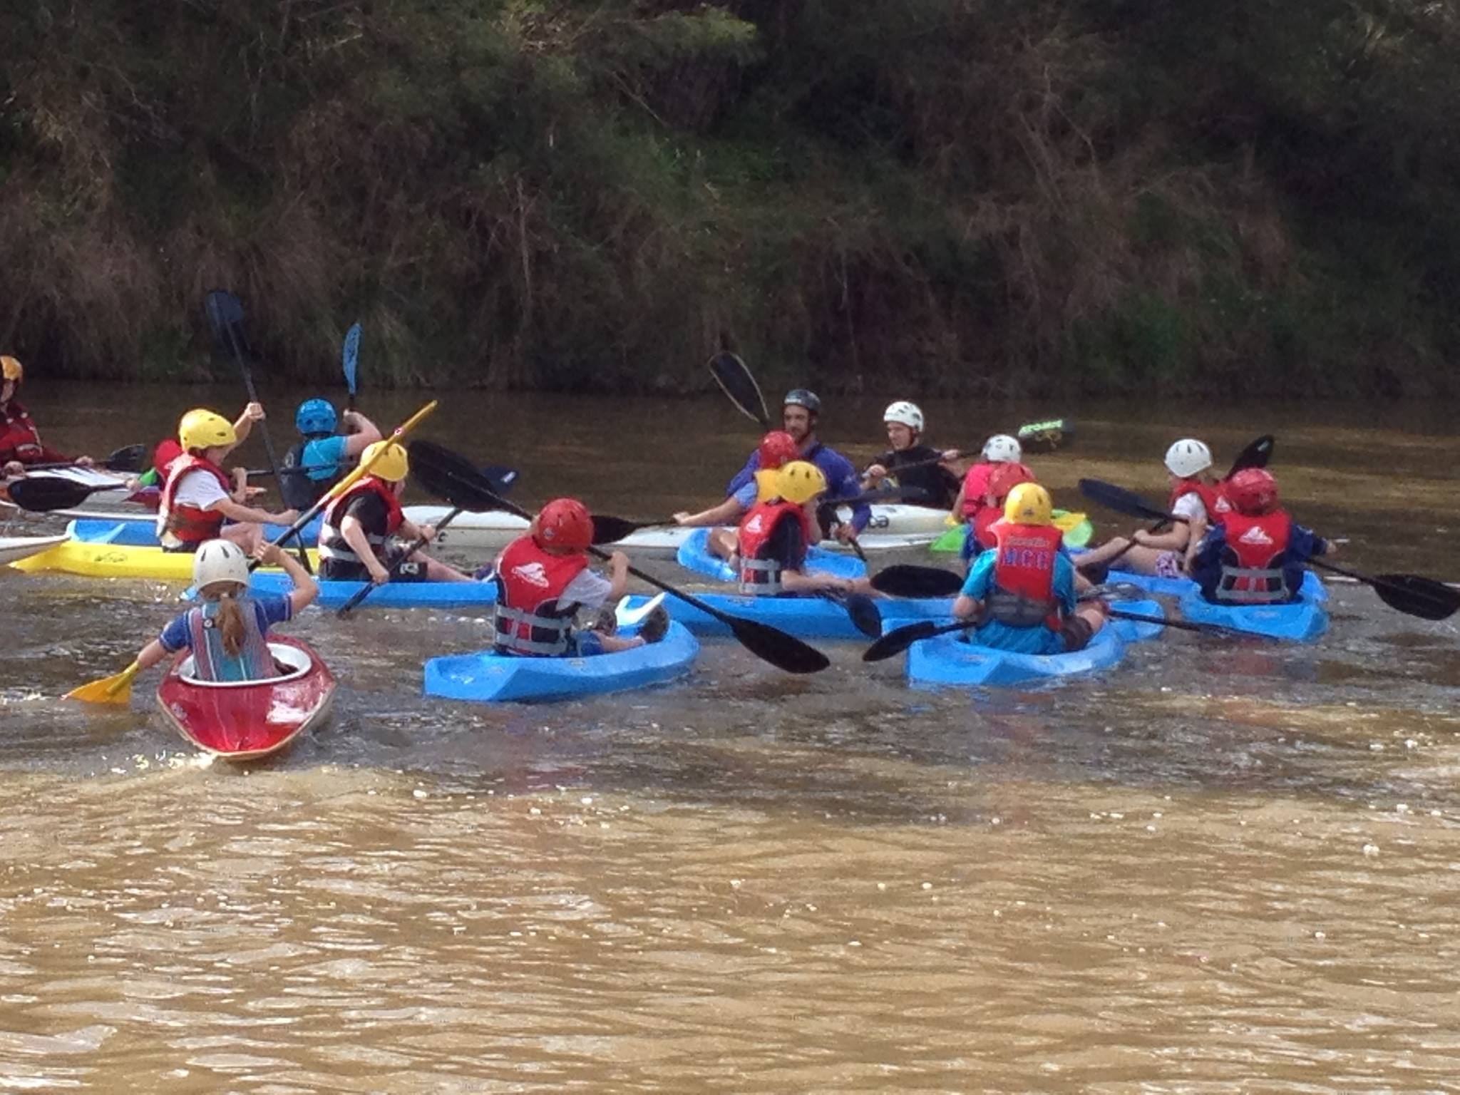

Contents
Acknowledgements 2
Membership 2
Affiliated Clubs 2
Office Bearers 3
Vale 4
President’s Report 5
Finance Report 7
Executive Officer’s Report 8
Administration Report 10
Paddle Victoria Volunteer Awards 12
Marathon Report 14
Canoe Polo Report 17
Sprint Report 18
Slalom Report 19
Wildwater Report 23
Club Events 25
Audited Financial Statements 30

Acknowledgments

Paddle Victoria acknowledges and thanks the following organisations for their support during 2018-2019:

Major Supporters
- Victorian Government, Sport and Recreation Victoria, Department of Health and Human Services
- VicHealth
- Life Saving Victoria
- Melbourne Water
- City of Manningham

Supporters
- Paddle Australia
- Australian Sports Commission
- City of Greater Geelong Council
- Outdoor Education Group
- Parks Victoria
- Murrindindi Shire Council
- Shire of Strathbogie
- Greater Shepparton City Council
- Vicsport
- Victorian Institute of Sport

We would also like to acknowledge the support of the
hundreds of volunteers across our canoeing community.

Front cover Photos: Sprint at Nagambie – Photo by Liesl Woods

Polo Competition

PaddlePower on the Yarra

Slalom Junior Championships – Photo by Andrew Stamp

Membership
 |  |  | 2018-19 |  | 2017-18
Full Adult |  |  | 555 |  | 526
Recreational Adult |  |  | 785 |  | 798
Life |  |  | 7 |  | 9
Full Student 18- 24 |  |  | 71 |  | 80
Full Junior U18 |  |  | 222 |  | 202
Limited Youth |  |  | 195 |  | 221
Social/Non Paddling |  |  | 31 |  | 39
Total |  |  | 1866 |  | 1875

Affiliated Clubs
Ballarat Amateur Canoe Club
Barwon Heads Canoe Club
Bellarine Paddlers Inc
Bendigo Canoe Club
Coaching Evolution Kayak Club
Canoes Plus Racing Team
Cobram-Barooga Canoe Club
Echuca-Moama Canoe Club
Eltham College Canoe Club
Essendon Canoe Club
Fairfield Canoe Club
Footscray Amateur Canoe Club
Geelong Canoe Club
Goldfields Paddlers Inc
Ivanhoe-Northcote Canoe Club
Kananook Creek Canoe Club
Kirinari Kayak Klub
Melbourne Canoe Club
Melbourne University Mountaineering Club
Mercantile Kayak Club
Mildura Canoe Club
Mitta Mitta Canoe Club
North East Canoe Club
Patterson Lakes Canoe Club
River Racing Australia
Shepparton Canoe Club
Swan Hill Canoe Club
Tarwin River Canoe Club
Victorian Canoe Club
Victorian Sprint Paddlers Inc
Warrnambool Kayak Club
Whitehorse Canoe Club
Yarra Valley Kayaking (X- Sherbrooke Knox CC Mar’18)
Yarrawonga Mulwala Canoe Club

Office Bearers

Board

Administration Staff
President, Chair & Interested Director | Paul Grant (2016)
Interested Director  Interested Director  Interested Director | Kate Leverett (2018)  Reka Abraham (2017)  Dita Pahl resigned
Independent Director | Lawrie Chenoweth
Independent Director  Independent Director | Paul Loughran  Georgina Wakim (2017)
Executive Officer | Mark Heggie
Finance Officer | Sandra Reaburn
Membership & Club Administration Officer | Roz Manester
Education Business Manager | John Moore
Education Administration Officer | Roz Manester
Equipment Maintenance Officer | John Shields
Communications Officer | Megan Macko
Project Manager | Sharon Swoboda

Discipline Technical Committees

Marathon
Chair | John Young
Vice Chair | Joseph Alia
Treasurer  Secretary | John Young  Sue O’Rourke
Technical officer | Geoff Baird
Communications  Diary | Arabelle Eyre  Sally Miller

Polo
Chair  Equipment Control  Development Coordinator  Comms Coordinator  Pool Coordinator  Nationals Coordinator  General member  General member  General member  General member | Dale Tomlinson  Larry Robb  Jade Kerber  Ben Watts  Ben Watts  Jade Kerber  Dale Tomlinson  Ian Beasley  Frank Magee  Ken Brownlee  Michael Jarman

Slalom
Chair  Chair | Russell Bassett Feb 19  Chris Runting March to current
Secretary  Treasurer  General Committee  General Committee General Committee Athletes Rep | Sue Moorhen  Lyne Strmecki  Laura Montalto  Chris Galea  Chris Runting  Warwick Draper

Sprint
Chair  Vice Chair  Secretary  Treasurer | Rowan Doyle  Laurie Chenoweth  Georgina Wakim  Gary Flanigan (until 29 Jan 2019)

Wildwater
Chair | Chris Wharton
Secretary | Lyne Strmecki
Committee Member  Committee Member | Roger Douglass  Warren Elms
Committee Member  Committee Member  Committee Member  Committee Member  Committee Member  Committee Member | Roy Farrance  Damien Guthrie  Neville Humphy  Wes Hurrey  Tony Mission  Dita Pahl

Vale: John Lidstone
This year we lost one of our treasured paddlers John Lidstone. Greg Parker was kind enough to send some information on John.

John Lidstone’s paddling career spans over four decades. John had competed in Kayak, Surf Club and Dragon Boat events his entire Adult life. John was a life member of both Geelong Canoe Club (6 years) and Jan Juc Surf Life Saving Club. To list all John’s events would be a task in itself, but here are just a few –
Australian Kayak Tiles and Masters Games Events in QLD, NSW, ACT, VIC, TAS & SA
World Masters in Spain, Singapore and New Zealand
Dragon Boat Representative in China

John was always a Gentleman!

Vale: John Moss Boardman
Kirinari Kayak Club
Passed away suddenly on 13th January 2019
Aged 89 years
John was a most kind, gentle and selfless man who will be sadly missed.

Vale: Michael Vane Goyne
Gippsland Waters Canoe Club
15.5.1938 – 5.9.2018
Michael passed away peacefully surrounded by loved ones at the West Gippsland Hospital, Warragual after a long illness.

Vale: William (Bill) Dunn
Cobram Carooga Canoe Club

Born on July 10th 1940, Bill passed away on the 8th September 2018. Bill was a famous Murray Marathon Paddler who passed away peacefully at the Austin Hospital surrounded by his family.
“Keep you paddle wet and your powder dry”

President’s Report

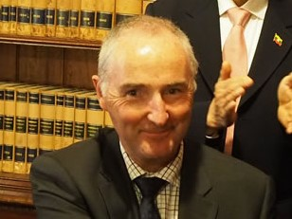

Paul Grant - President
This time last year I reported as Canoeing Victoria for the last time as we saw the implementation of our name change to Paddle Victoria. In line with the national body, the change of name was to reflect a change in direction and inclusion of other paddling activities but the reality is we won’t see a discernible change in the short term but position ourselves for future growth in such a diverse market. Programs such as PaddleHub, PaddlePower and Kayak Paddleball are examples of where we are embracing the ever growing sit on top market with the end game of more people falling in love with paddling in any form and becoming a permanent member of our community.
In addition to the name change however, the Board has been rather challenged with many other proposed changes some of which have been implemented, including a change in our membership database. I’d like to thank the members for their patience as we undergo this transition and understand that sometimes technology doesn’t necessarily work as it should to start with but look forward to the new process streamlining the member procedure.
Change doesn’t come without cost unfortunately, and the changes over the last 12 months have resulted in the organisation posting a loss of $1000 which is not actually reflective in the true cost of the changes, but due to strong financial management and the juggling of activities where possible. The income stream is a combination of membership fees, state government grants, education programs, and some minor entities. The expenses have been held to a minimum and we are living within our means.
In addition, the Board did have an unwanted focus on behaviour and the culture of our sport which did however, provide the Board and the membership the opportunity to reflect on what we want to be as an organisation and conduct ourselves in the future as the popularity of paddling increases not only in Victoria but nationally as a whole.
The popularity of paddling in the general population hasn’t unfortunately been as reflective in our membership as we have hoped with only a small growth over the year. This should be a focus for the organisation moving forward by embracing all the different aspects of paddling. As Paddle Australia tries to address this issue as well, the discussion of some form of the unitary model continues, to strengthen and support all areas of paddling in nationwide. To this end, Paddle Victoria are contributing to the discussions and development in various forums on what this will look like but at the end of day the Victorian members are the ones we serve and will continue to support.
With that in mind, I would like to acknowledge the work, expertise and loyalty of the staff at Paddle Victoria. Unusually, our office is filled with staff that have been with the organisation for many years. Sandra Redburn has been employed by the office for over 18 years and as a result we have excellent and stable financial management. Sandra can report down to the last cent where money has been spent, on which program, understand where programs and activities are profitable, what is good value for money and is a shrewd negotiator.
Roz Manester is well known for her exceptional people skills and customer service which all those that have dealt with Roz would attest to. For 8 years Roz has enabled a constant point of contact, is extremely knowledgeable on all things membership and database for clubs and members as well as revived the education department by ensuring member equipment works hard engaging more people paddling and promoting the pathways to clubs.
Our resident project manager Sharon Swoboda has also been with the organisation for many years managing the VicHealth and Sport and Recreation Victoria projects from the days of the Sunsmart campaigns in 2002 right through to the current VicHealth innovation funding - designing and implementing Kayak PaddleBall – a program targeting the teenage paddler to whom we currently have little engagement. Sharon continues to bring many years of knowledge and expertise to the organisation having played the role of Executive Officer in the past as well.
From 2007, John Moore has been the education consultant on all things to do with programs and instructors. With his office really on the water, John’s provides a broad skill set, knowledge and great support to those that underpin the development of the sport. Every year we receive many glowing feedback reports from those who have been fortunate enough to meet up with him. He is a real asset.

And then there is the Executive Officer. One of the hardest roles within the organisation and we are very lucky to have Mark Heggie leading the helm for the last 3 years. His excellent people “soft” skills are a great asset to the organisation as he negotiates his way through such a varied array of situations. With the support of Megan and Steph in the communications team, Mark represents the membership with integrity and honesty and sets the highest standards for decency and respect.
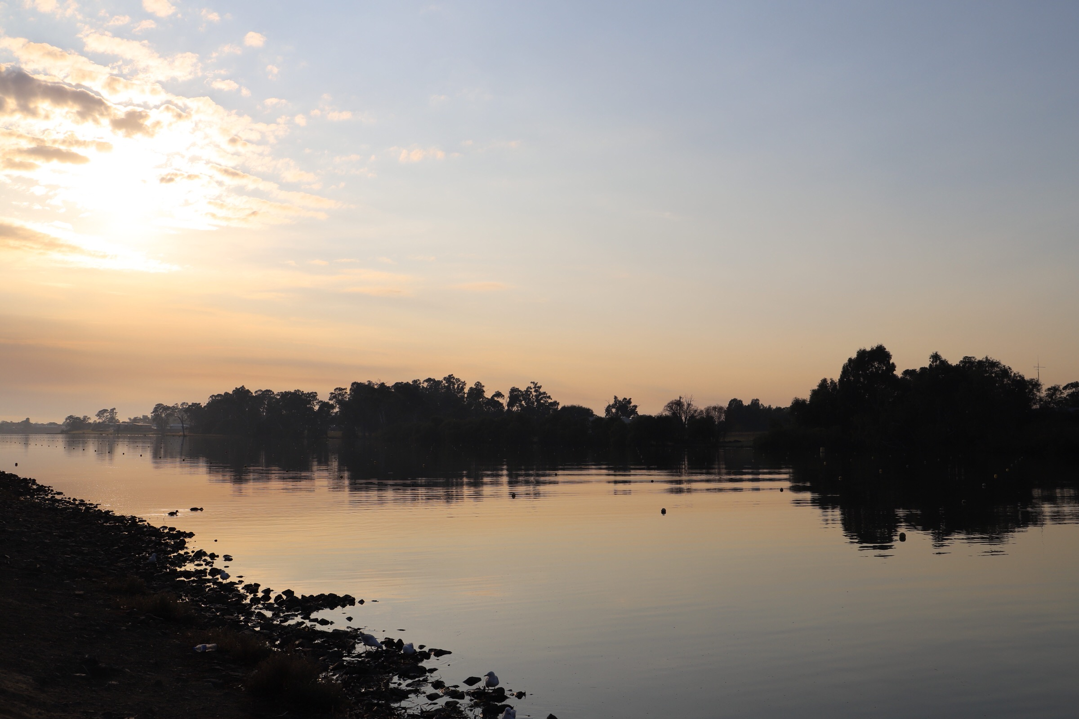
In addition to their individual roles, the entire team within the office is renowned for their flexibility - being available at the most inconvenient times yet convenient to volunteers, their ability to multi skill, all on an extremely tight and limited budget. They understand the whole of the sport, across disciplines, the public and their motivations, schools and their demands but most of all the members. They are fierce supporters of the members and ensuring the opportunities to participate continue and for this I thank them on your behalf.
The Board is made up of everyday people who have volunteered their time and expertise to keep this juggernaut rolling. We provide support for the office and are an important link in a national framework. I would like to thank the board for their ongoing efforts.

The financial position of Paddle Vic Administration is stable and sound. We are not seeing much growth in numbers and income .This year we had an income of $329K and an operating loss of $1K in comparison to last financial year where we had an income of $327K and an operating profit of $1K - which are percentage wise very close. So we are neither growing nor shrinking. It would be preferable to be in growth and the main way we see this happening is via education programs which concentrate on the paddlers of tomorrow.
The income stream is a combination of membership fees, state government grants, education programs, and some minor entities. The expenses have been held to a minimum and we are living within our means.

The Unitary Model of management is one of the main areas of change on the horizon with Paddle Australia at the moment and that will be further defined over the coming year.

The Board is made up of everyday people who have volunteered their time and expertise to keep this juggernaut rolling. We provide support for the office and are an important link in a national framework. I would like to thank the board for their ongoing efforts.

Paul Grant

Nagambie ready for a paddle

Finance Report

This year the association posted an operating profit of $3,496.00 for the financial year 2018-2019. This was a huge improvement from the previous year’s loss of $8,126.00. The losses that were made this year by the office, Polo, Slalom and Wildwater were minimal which helped with the surplus. Once again Marathon made the most profit of $4,519 for the year.
The office would like to thank the Victorian Government through Sport and Recreation Victoria and VicHealth for their strong financial support. Without this support we would not be able to deliver the many projects we have in the pipeline to get people on the water and enjoying paddling.

Administration
We had a forecast budget projection of a loss of $16,531.12 but due to the excellent work of Roz Manester in Education who made a $7,944 profit and the constant support from our funders we were able to bring the loss back down to $1097.00. Our retain surplus is now $119,833. (includes assets etc )
Part of our loss was due to the extra work that was involved in the new membership database. This was an expense to the office of $5,315.00. Please keep in mind that we are still paying Paddle Australia $42,819.00 ext gst in affiliation fees which is nearly half of our membership income. We are also in the process of rebranding to our new name of Paddle Victoria which is an expensive process as well.
This year’s membership was the same as 2017-2018 financial years which is still down from previous years.
I would like to thank Gary Flanigan and his team for supporting the office in Bunning’s BBQ fundraising of $1,591.00 which we are extremely grateful for.

Marathon
This year Marathon made a surplus of $4,519.00. Their events were all very profitable and very well organised through Webscorer and the Marathon team of volunteers headed by John Young. With Marathon’s surplus they were able to invest and update their trailer and safety boat. They have increased their retained surplus to $62,605.00

Polo
Polo posted a loss of $201.00 which was a huge improvement from last financial year’s $12,002.00
loss. This is due to Polo not receiving the pool hire invoice until October 2019. Unfortunately this will have significant effect on the next financial year. Polo invested in new goals for the future at a cost of $5,000. Polo is maintaining a healthy retained surplus of $87,113.00

Slalom
This year Slalom posted a loss of $1,500.00. They were fortunate to receive a $10,000 grant from Sport and Recreation Victoria to help them run the Junior National Championships. Slalom invested $17,600.00 into the Goulburn repairs in time to run the Nationals. The Yarra Series and School Champs all made profits. Slalom’s retained surplus is $28,762.00.

Sprint
Sprint posted a profit of $2,658.00. This profit was contributed by the new committee organising fundraising $1,114.00 with help of Gary Flanigan and the profitable events they helped to run. These events were the Victorian School Championships and the Victorian Championships. Sprint has a retained surplus of $8,375.00.

Wildwater
This year Wildwater made a loss of $883.00. This was mainly due to their generous contribution towards supporting their teams. All Wildwater events held through the year made a slight profit. Wildwater retained surplus is $6,719.00

Sandra Reaburn

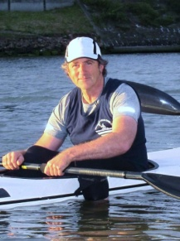
Executive Officer
Mark Heggie

The only thing that seems constant is change and the demands and trends that alter the environment we operate in to create new challenges each year.

One of the requirements of my role is to attend forums and workshops hosted by our funders such as Sport and Recreation Victoria and VicHealth. The most constant aspect I am reminded of is the challenges we face are often the same across many Sporting and Recreational organizations.
There is so much competition for time and attention, many new sports and recreational pursuits that capture the public’s imagination.
We are not big enough to compete against the noisy aspects of commercial sports and better known sporting activities, so we have to look at our resources and utilize them as best we can. Our greatest resource is our people and at all levels our activity is driven by the people who run the clubs, run the disciplines, commit to becoming qualified coaches , officials, leaders and educators.
We have so many passionate people who carry on the previous aspirations of the founders of our sport in this country. Fairfield Canoe Club recently celebrated 100 years and we have many other clubs such as Essendon Canoe Club from the same era, and a raft of clubs that are more than 50 years old.
As I was working on preparing arguments for the funding of a new club building, I looked into the membership history of a 55 year old club. Without being able to get accurate unique numbers I would propose the club would have hosted many thousands of members over its history. Clubs have been and will always be the pillars of our sport and clubs are run by people.

Paddling is about people who are connecting with each other in a unique environment, enjoying all the aspects we as paddlers celebrate.
As administrators of the activity, Paddle Victoria and Paddle Australia have the responsibility to assist and provide an established structure for our clubs and disciplines to work within.
Whilst paddling is a comparatively free sport not always needing conventional large scale infrastructure we now conduct our activities on spaces that are under the jurisdiction of bodies such as Melbourne Water and all the Regional Water Authorities, Parks Victoria, Marine Safety and Councils. Paddle Victoria communicates and lobbies with all these authorities so clubs, disciplines and leaders can get on with what they are great at - paddling and running events.

The various disciplines that make up our sport in Victoria have all been working at different aspect to answer their various challenges.

Marathon under the chair of John Young and supported by an ever increasing team of inspired volunteers have gone on progressing at all levels. Numerous events over the breadth of the state are attended by appreciative paddlers. The committee has worked to support athlete development hosting training workshops. Marathon manage to keep their vital rescue boats up to date ensuring events can be run compliant with the highest safety standards. John, Geoff Baird and Joe Alia have been supported by young generation of volunteers such as Arabella Eyre.

Slalom Committee has carried on from the previous year’s achievements with Chris Runting taking over from Russell Bassett who has progressed to national and international Slalom Official roles.

The Victorian Sprint Committee efforts of getting athletes to GP events and developing a coordinated training strategy have been recognized with support from Paddle Australia to run team boat camps and get a group of Athletes to GP2 in Adelaide. The initial new committee from the previous year has consolidated in to an active unit with many plans for Victoria to re establish a presence in the national sprint scene.

Canoe Polo has been actively seeking and using new venues for regular competition and training.
They are active and willing to experiment with new sites and are working to activate sites with public exposure to show case, arguably, our most spectacular discipline.
Wildwater have formed a new committee and are looking forward to more national events, support and direction from the newly formed Paddle Australia Wildwater Committee.

Paddle Victoria Office
Paddle Victoria, supported by Vic Health and SRV, have run numerous participation programs throughout the state. PV has also run programs, self supported pay to paddle events catering for specific clients.
Projects person Sharon Swoboda was successful in gaining a VicHealth Innovation Challenge Grant. Sharon has developed an exciting game Kayak PaddleBall. The grant is specifically for targeting the challenging inactive 14-18 year olds. The game is fun and accessible, playing a simplified adaptable form of Canoe Polo on sit on tops. Experience is showing the game is fun and engaging and is a great tool for clubs and leaders to have to keep those early paddling sessions fun. The plan is to have the game a recognizable brand and teenagers exposed to it through school camps, scouts, youth etc. continuing on to become a league with multiple sites established.

Paddle Australia
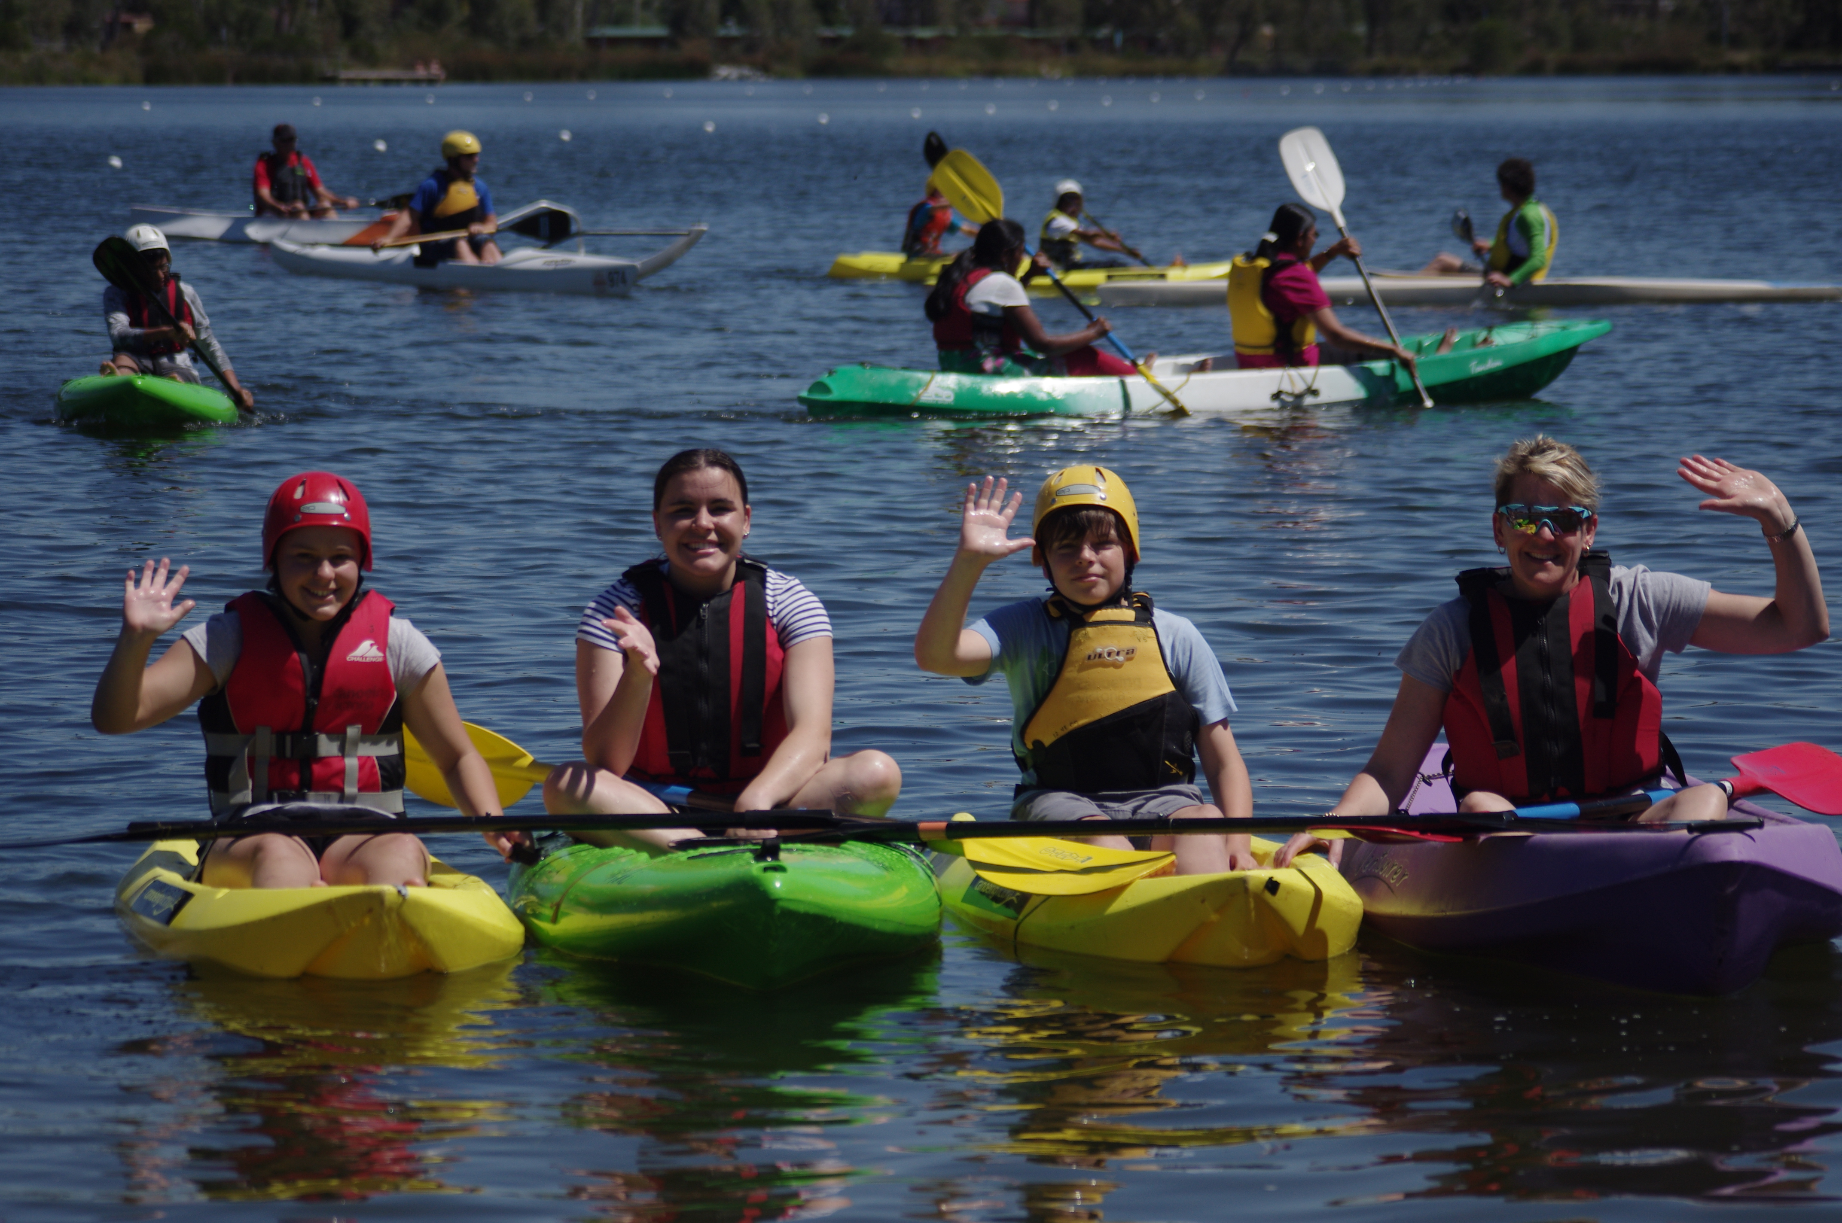
The year 2018-2019 saw the first of many changes that herald in the plans of Paddle Australia to set up our organizations to grasp future opportunities. In this period we have had the name change that has aligned the state names and national name under the “Paddle “ genre.
Exploration of an aligned membership model and the transformation to a new digital membership platform have commenced and are being enacted in later part of 2019 calendar year.
I am impressed with the way club officials and PV staff have engaged with the change process, participating in forums and training sessions.

Future Opportunities.
All levels of government from councils, state, federal and statutory authorities are wishing to have more people engaging in healthy activity levels. There are opportunities for Paddling in this space. Paddle Victoria supported by VicHealth is a leader in developing innovative participation programs. Long term experience in this area means we have packages prepared for numerous programs.
Costing, equipment and game plans are all available for clubs and providers to move quickly in to this space when opportunities arise.

Thanks - As I said at the beginning of this report, people make our community and I thank everyone who participates and contributes across our community.
I appreciate the support of all my office staff and coaches. They constantly demonstrate their commitment and passion for all the benefits of paddling. The Board volunteers generously and contribute their time and skill to support me in my role.

Across our community, I am heartened when I see the positive, supportive and respectful way personal interactions can occur.

I would commend all of us to reflect on the benefits of maintaining the highest levels of respect in all our interactions.

Executive Officer
Mark Heggie

Administration
Membership
I am happy to report that we did reach the membership numbers we had budgeted for in 2018-19.
Interestingly our Competitive Membership Numbers were up in a year that saw Recreational memberships fall slightly.
Membership numbers however have stayed mostly constant over the last 3 years.
Sherbrooke Knox Canoe club joined forces with some paddlers in the Warburton area and merged to become Yarra Valley Kayaking inc.
Canoe Factory club became very small and decided to disaffiliate, and we gained one new Club from Gippsland. We welcome Float Inc to Paddle Victoria’s list of 34 affiliated Clubs.
During the year we started to look at a change in our membership structure and informed members of Paddle Australia’s intention to replace the current membership platform SDNA, to a new Membership and Events Portal – Go Membership. The impact of
these changes will be investigated during 2019-20 and reported on at next years AGM.

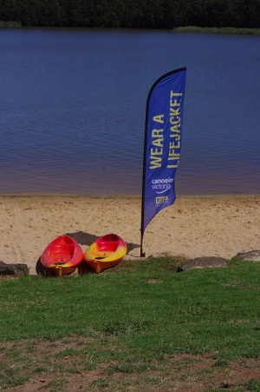
Education

The Education Department at Paddle Victoria seems to expand yearly with new programs being added and new Coaches, Guides and Instructors coming on board. This year we have seen PaddlePower (Ages 7-14) grow to include many more School Holiday programs in 6 Clubs and 3 of these clubs offering Term Programs to get young paddlers into the sport. PaddlePower continues to be a very popular program and clubs are encouraged to get involved. Paddle Victoria can offer all the resources that you will need.
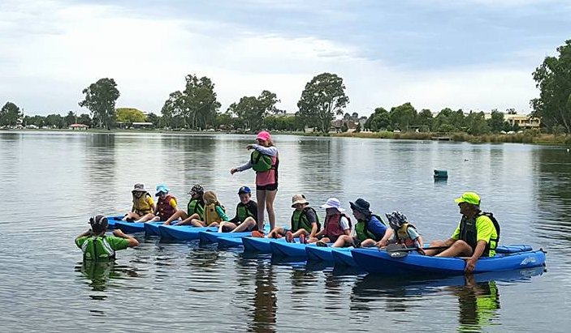

PaddleHub and the Ladies River Rambles are both expanding programs, increasing in popularity and offering the recreational paddler a fun, safe and social time on the water. Again Clubs are encouraged to contact Paddle Vic to get involved in running these programs.

2018-19 saw our schools program expand to include new schools who have really enjoyed the varied and many programs that we can offer here at Paddle Victoria. These schools programs range from Paddlepower sessions in pools and lakes, to flatwater game based programs, basic skills and whitewater river trips. Our hardworking coaches and guides had their work cut out for them when they delivered Paddlepower to 150 children in one day over 6 sessions – an entire Primary school! Then there are the challenging river trips in Kayak and Double canoe, which the Secondary students really enjoy as they paddle over rapids on the Yarra River!

In addition to all this we run the Paddle Australia Qualification Scheme (PAQs) and deliver Paddling Supervisor, Flatwater Guide and Whitewater Guide Programs. More and more the Victorian Education Department is recognizing the value of the PAQs qualifications and we are qualifying more Flatwater and Whitewater Guides.
We ran our annual Flatwater and Whitewater Coaching course and had 15 young enthusiastic club members join us. The Coaching course is run annually and we encourage Club members to get involved with coaching at their club. Having skilled club members assists to share the load in inducting and coaching new and developing members in your club.

After a really busy year, we were happy to report a profit of $7,944.00. Much of this money will be put back into upgrading our equipment so that our programs and facilities stay current in an ever increasingly competitive space.

Membership and Education
Roz Manester
Kayak PaddleBall
Sharon Swoboda – Project Manager
Paddle Victoria was fortunate to be successful in receiving funding from Vic health in 2018-19 from their Innovation challenge program to develop Kayak PaddleBall with funding for this program finishing in December 2019
From our previous experience of PaddlePower and PaddleHub, we had quantifiable evidence that as a paddling community there was no entry level social paddling activity that was available or attractive to the teenage age group between 14-18 years of age. Both these programs were highly successful in targeting the under 14's and their parents. Out of the 1000’s of PaddleHub participants less than a handful were within the teenage age bracket.
Canoe Polo was the ideal game to attract this age group but was re-examined to develop an activity that addressed the initial barriers to participation by removing the paddling skill requirements, reducing the ball skills and creating an element of social engagement and low cost to become an attractive and accessible activity.
The result is Kayak PaddleBall, a sit on top version of Canoe Polo, a 5 aside, no catching, no boundary, modified goal activity to encourage a fun and social activity out on the water not only for teenagers but for all ages to play but specifically targeting teenagers.
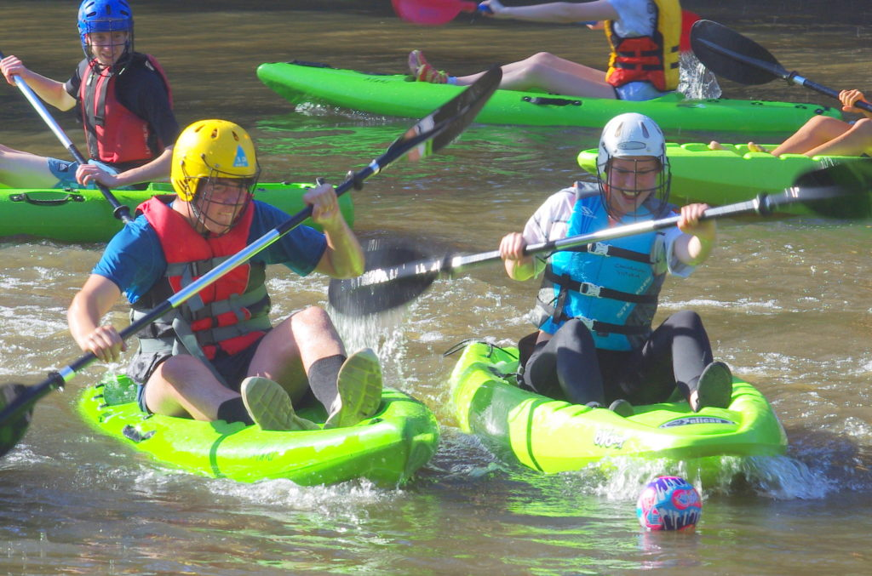
VicHealth's Innovation Challenge is different to their other participation funding programs, structured differently to support organisations to take a new and innovative idea to fruition. They provide business and marketing support as well as regular catch ups with the other recipients so as to leverage off each other’s learning’s.
The Kayak PaddleBall program had a slow start with a change of approach midway as the original approach did not gain traction. Despite reports of those who played the game being enthusiastic, to get the target age group to participate in the first place was highly challenging. The second half of the program saw a change in approach, timing amended and has had a greater success as a result.
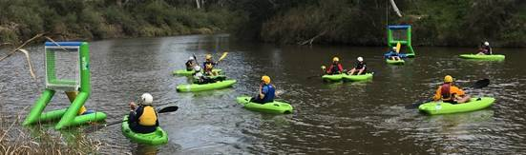
The game itself has great promise as not only a lead in activity for canoe polo but as a great standalone activity for both clubs, organisations, schools, regional pools and school camps to attract the teenagers and add to the armoury of activities for all ages to engage with. In addition, we have seen 3rd parties such as Sydney Harbour Kayaks take up the game as well as it being included in the Paddle Australia participation funding from Sports Australia which is a nationally implemented program.
For the latter part of the funding we will see the game delivered through schools, scouting groups, community groups, regional pools and waterways, local council programs and regional victories schools.
The future pathway to deliver Kayak Paddleball Challenge or gala days to bring a focus to the social component as well as provide the pathway to Canoe Polo and International competition. It can be a tool for outdoor educator deliverers to engage everyone in a different type of paddling, for clubs to continue engagement after a junior paddling program and as an activity by waterway mangers to attract increased usage of their facilities.
The vision is to support clubs, community groups and councils to own sets of the low cost, easy to paddle sit on top sets that are made available for participants to reduce the need for individual purchase and have the activity delivered in free or low cost venues (such as outdoor lakes and waterways) which address a major barrier being cost.
The future of Kayak Paddleball - under whatever name it undertakes is exciting at the very least and we extend our thanks to VicHealth for their support and look forward to 5 years down the track when it is well established and part of a new paddling landscape.
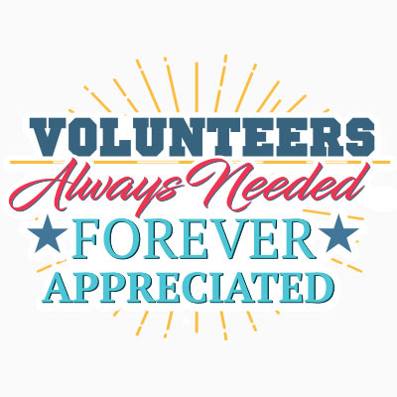
Paddle Victoria
Volunteer of the Year Award – 2019
Volunteering is time willingly given for the common good and without financial gain.
Another successful year in our Disciplines, in our Clubs, at races and events for competition and recreational paddling would not be possible without the many unselfish acts of volunteering by our wonderful members and their families
The Paddle Victoria Volunteer Awards recognize and celebrate Paddle Victoria’s volunteers who have demonstrated an outstanding contribution within our paddling community.
The nominees for the 2019 Paddle Victoria Volunteer award are:

Geoff Burkitt – Whitehorse Canoe Club

Geoff has contributed to the development of novice and inexperienced paddlers of all ages and abilities. He is very passionate about teaching paddlers the skills to paddle moving water. Geoff volunteers his time to run regular Yarra River Trips targeted at whitewater beginners throughout the year. He also volunteers his time to teach inexperience kayakers how to roll through running regular pool rolling nights.

Geoff helps paddlers make the jump from doing the occasional Flatwater trip to being confident and safe whitewater paddlers. This transition can be daunting for anyone, but even more so for mature adults who need just the right amount of support and level of challenge to build their confidence and skills on moving water. Through Geoff’s ongoing commitment to developing novice whitewater paddlers, he ensures that paddlers of any age can experience the great thrill and joy that comes with recreational whitewater kayaking

Geoff provides feedback to the paddlers to assist them in improving their skills. This includes using an ipad to provide feedback on rolling technique so that the paddlers can visualize where improvements are needed.
Geoff’s number one priority is to provide a safe environment for all kayakers to learn in and enjoy the water ways.

In addition to all of this, Geoff is also the Treasurer of Whitehorse Canoe Club, and attends to all membership related matters. He spends countless hours both on and off the water supporting recreational whitewater kayaking in Victoria.

Mitchell Payne – Geelong Canoe Club

Mitchell has been a longstanding club member with Geelong Canoe Club. His roles have included Executive Committee, Boat Captain and Facility Management. He provides weekly coaching to novice and intermediate paddlers and is always working behind the scenes with grant applications. The grant applications have significantly helped Geelong Canoe Club improve the club house building. His role as Boat Captain allows Mitchell to be involved with the maintenance of club craft.
Mitchell is a great example of a true sportsman and is dedicated to paddling.

Tony Misson – Bendigo Canoe Club

Tony has been a long term member of Bendigo Canoe Club and has enjoyed the range of disciplines that are on offer. Tony is secretary of Bendigo and is heavily involved in organising the Come & Try’s, trips, recreational programs and is head coach to Bendigo Academy of Sport. Outside of the club Tony is on the Paddle Victoria committee of Wildwater and Sprint and the Paddle Australia advisory committee for Wildwater and is a level 2 Flatwater coach which all keeps him very busy.
Tony is involved in the Club junior development with the Bendigo Academy of Sport and the recreation paddling program for adults. There is normally two sessions per week from October to May and at least 1 hour per week organising activities and events. Tony has introduced sea kayaks for come & try’s, inductions, instruction, skills, trips and events and has revolutionised the way adults are introduced to the club.
Tony has been a huge asset to the club in every way and is a fantastic mentor to all our members.

Cynthia Coakley – Bendigo Canoe Club

Cynthia has been with Bendigo Canoe Club for quite some time. For the past 3 years Cynthia has delivered the K4K junior program. The Kayaking 4 Kids program has addressed an important gap in the club programs. This program is teaching 10-14 years the skills they need to enjoy the sport. The program is based on providing appropriate skills with the goals to paddle a TK1/TK2 safely with good technique and to be involved in club events and community paddles. This program caters for all abilities and is very focused on safety as well as having fun. Cynthia runs this program twice a year over a period of time and provides the committee with a detail report which assists in providing the best support for the juniors.
Cynthia provides appropriate goals such as the community fun paddles and will catch up with the K4K juniors at the weekly events. She has been a great mentor to our up and coming paddlers.

John Young – Ivanhoe Northcote Canoe Club

John is heavily involved in organising all the marathon races throughout Victoria. By John doing this it ensures Marathon paddlers get a wide range of race experience over a broad spectrum of locations. John is always looking for ways to include more participants across different regional areas and age groups. He is also diligent in organising support for safety boats and first aid during all the events. John runs a very organised and efficient event and by doing this has increased the revenue to the Marathon Committee.
John is constantly attending training sessions with other members and has a wealth of knowledge in all aspects of the sport.
John is always happy to assists any new committee members and participants in learning the ropes and getting more people paddling.

Barry Bell – Shepparton Canoe Club

Barry has been nominated because of the generous hours he volunteers toward the ongoing improvement to the Shepparton Canoe Club and all the members. As President he is constantly liaising with Paddle Victoria with regards to running and coordinating the Paddlepower and PaddleHub projects that have come to Victoria Park in recent years. He also has been working with Shepparton Council to conduct ladies and multicultural paddling events. This has enabled the local community to enjoy not only the beautiful lake but have fun learning to paddle.
None of this would be possible without the drive and determination of Barry.
Barry is the first at the club and last to leave. He is the clubs repair man and often takes on some of the members personal fibreglass repairs free of charge. Barry has organised club working bees and maintains a high standard at the Club. Barry was instrumental in working with Paddle Victoria to apply for a grant so the Club could purchase new lifejackets and helmets.
He continues to encourage our younger less active members the health and mental benefits that come with paddling. Barry is an extraordinary clubman and deserves to be recognised as a remarkable volunteer.

Marathon Report
John Young

As noted last year, the primary focus of the Marathon Committee was to provide a high-quality racing experience for all levels of competitors and to foster the development of junior paddlers. The Committee works in conjunction with host clubs to hold a Summer race series, a Winter race series and state and school championship events. Twenty-two marathon races were scheduled (and twenty held), with some marathon paddlers also participating in sprint, river/wildwater, multi-sport and ocean racing events.

Race attendance
Race attendance varied markedly, depending upon race location and school involvement, ranging from as few as 29 up to ~140 paddlers, with an average of 83. Average race participation decreased by 5% from the prior year, in part due to lower involvement at Nationals, which were in Perth (vs Adelaide), partly due to non-repeat of dragon boat participation in one race and low participation at two Winter Series country race events. Despite the wide range of events on offer, the proportion of Paddle Victoria members regularly competing continues to be small, and most paddlers only participate in one or two events each year. A small core participates regularly, and we deeply appreciate their support.
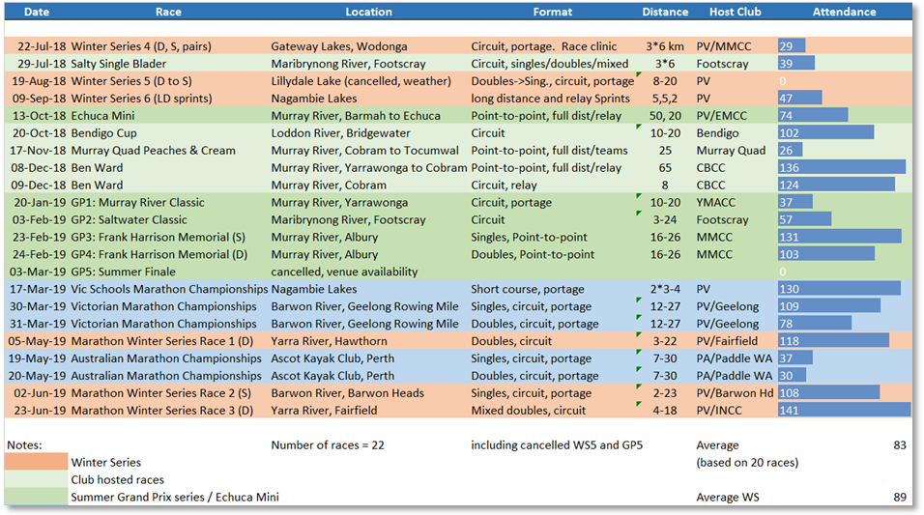
Table 1 FY19 Marathon race program and race participation

Championships events
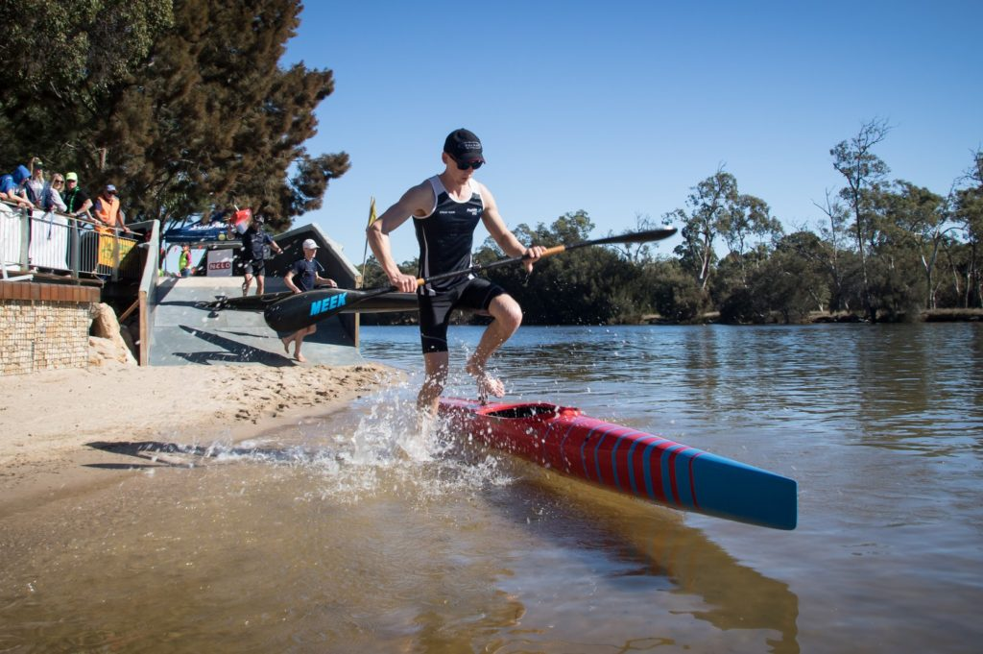
Three major championship events were an important part of the FY19 race calendar. The Victorian Schools Marathon Championships were held at Nagambie Lakes Regatta Centre in March, as a single day event in conjunction with the Schools Sprint Championships. The Victorian Marathon Championships were held over two days at Geelong Rowing Mile in late March, serving as the selection event for the Victorian Marathon Team for the Australian Marathon Championships and as a trial run for the Australian Marathon Championships that Victoria will host at this venue in 2020. The 2019 Australian Marathon Championships were held at Ascot Kayak Club in Perth over two days in May, with 39 paddlers from Victoria participating amongst over 263 individual entries from Australia. The list of paddlers placing first, second or third was previously published on 26th May, with 11 first, 7 second and 10 third places across singles and doubles. Brianna Jones (INCC) and Seamus Spanner (Barwon Heads) were awarded the 2018 Junior Female and Male Paddler of the Year.

2019 Marathon World Championships
Victorian performance at the 2018 Marathon World Championships in Vila de Prado, Portugal in September 2018 was covered in our annual report last year. The 2019 Marathon World Championships will be held in Shaoxing, China in mid-October and the results will not be available in time for this year’s annual report submission. Twelve of the 20 paddlers representing Australia are from Victoria, with a further two Victorians participating in the Masters World Championships, as shown below. This year is the first year that the Masters’ competition will be a World Championship status rather than a World Cup.
Table 2 Victorian participation in the 2019 Marathon World Championships and Masters World Championships
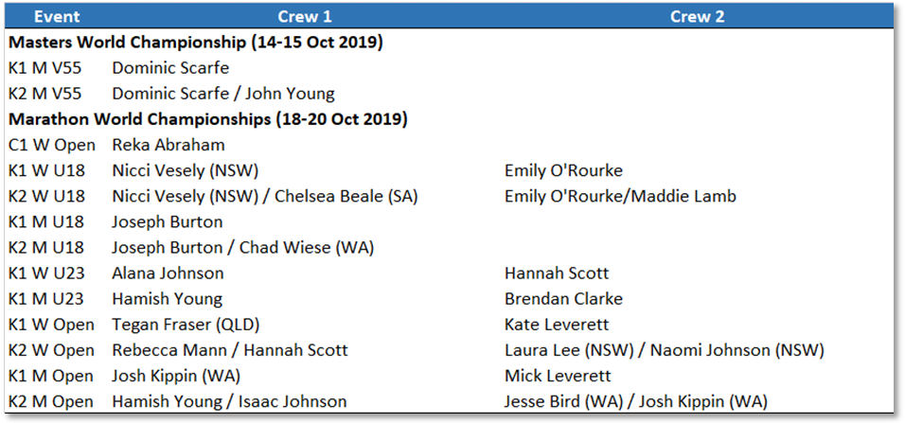
Junior development
As noted last year, introducing young people to paddling is critical to the ongoing sustainability of our sport. This continues to be our major challenge, with few Victorian clubs currently operating junior programs. One further challenge is to encourage the junior paddlers currently enrolled in the programs on offer to make the step and participate in competitive as well as social paddling.
Increasing junior participation at a club level and encouraging additional schools to offer paddling programs remains a key focus of the Marathon committee. The Marathon committee will run a further “Ready to Race” clinic during calendar 2019, building on the three clinics run in 2018, aimed at lifting the competition skills of our younger paddlers. As noted in the “achievements” and “initiatives” section below the Marathon Committee acquired nine doubles boats as part of its longer term plan to provide introductory secondary school race programs in the future.
Financial performance
The Marathon discipline was fortunate to make an operating profit of ~$4,500, again due primarily to good cost control and steady race participation. The result was down from the ~$8,000 operating profit in FY18 primarily due to the cancellation of one race (2018 WS5) due to bad weather. Marathon finished the financial year with net assets of ~$62,600 (FY18 ~$58,000), comprising cash of ~$42,000, equipment of ~$15,000 and prepayment of ~$3,200. During the year Marathon invested $8,500 in a new safety boat and trailer, offset by revenue of $1,000 from sale of the old safety boat and trailer.

Achievements/initiatives in 2018/2019
- Continued to promote marathon racing through regular pre-race marketing on social media and initiatives such as a focus on mixed doubles racing at WS3, which attracted over 140 participants.
- Introduced a new Paddle Victoria Marathon team wear, such as polos, rugby jumpers, hoodies, fleeces, merino tops, long sleeved tees, soft shell jackets, paddling tops and paddling caps to complement the PV Marathon racing uniform introduced in FY18.
- Introduced spot prizes at Winter Series and Victorian Championship races for paddlers and volunteers to encourage participation at post-race medal presentations. Spot prizes included team wear and free race entry at future races.
- Developed training material for Marathon race officials and conducted a half-day training workshop for race officials, followed by on-the-job training for Chief Official, Chief Course Umpire and Safety Officer roles at Victorian Championships and Winter Series events.
- Acquired eight TK2 and one K2 boats, together with some paddles and PFDs, to support the planned delivery of introductory secondary school paddling program in 2020.

Initiatives for 2019/2020
- Continue working with clubs to establish and energize junior programs at all clubs.
- Continue working with clubs to establish race coordinators to drive increased club participation at races.
- Hosting the Australian Marathon Championships at the Geelong Rowing Mile in April 2020.
- Seek grant funding for a kayak trailer, paddles and PFDs to support the secondary school paddling program.

Safety
The safety and wellbeing of all participants is the most important priority at our events. Through preparation and training we were fortunate that we had no medical treatment or loss time injuries and our events during the past year.

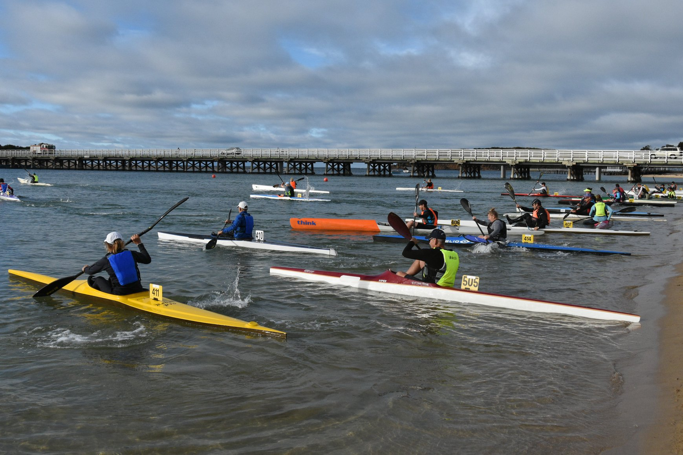

Photo: Frank O’Rourke

Acknowledgements
I would like to thank the members of the Marathon Committee, Joe Alia (Vice Chair), Sue O’Rourke (Secretary), Geoff Baird (Technical Officer) and those who assist the committee in project roles, Sally Miller (Marathon Diary), Arabella Eyre (communications) and Debbie Bennett (sport development), plus the many volunteers who willingly give their time to support our events, and without whom the discipline could not operate. I would especially like to mention the contribution of Ruth Graves who has handled registration and timekeeping for almost all, if not all, races since 2012, which is now well in excess of 80 events. There is probably not another volunteer (or paddler) who has attended as many races in that time. Space does not permit me to name all the others who have assisted this year, however, I would like to acknowledge the contribution of Arabella Eyre, Mike Neilson and Foster Rosetto as new race officials and to Peter Jones as Victorian team manager at the Australian Marathon Championships in Perth in May. Finally, I would like to thank all the paddlers that participated in our events and I look forward to their continued support in 2020.

John Young
Chair, Marathon Committee

Canoe Polo
Dale Tomlinson

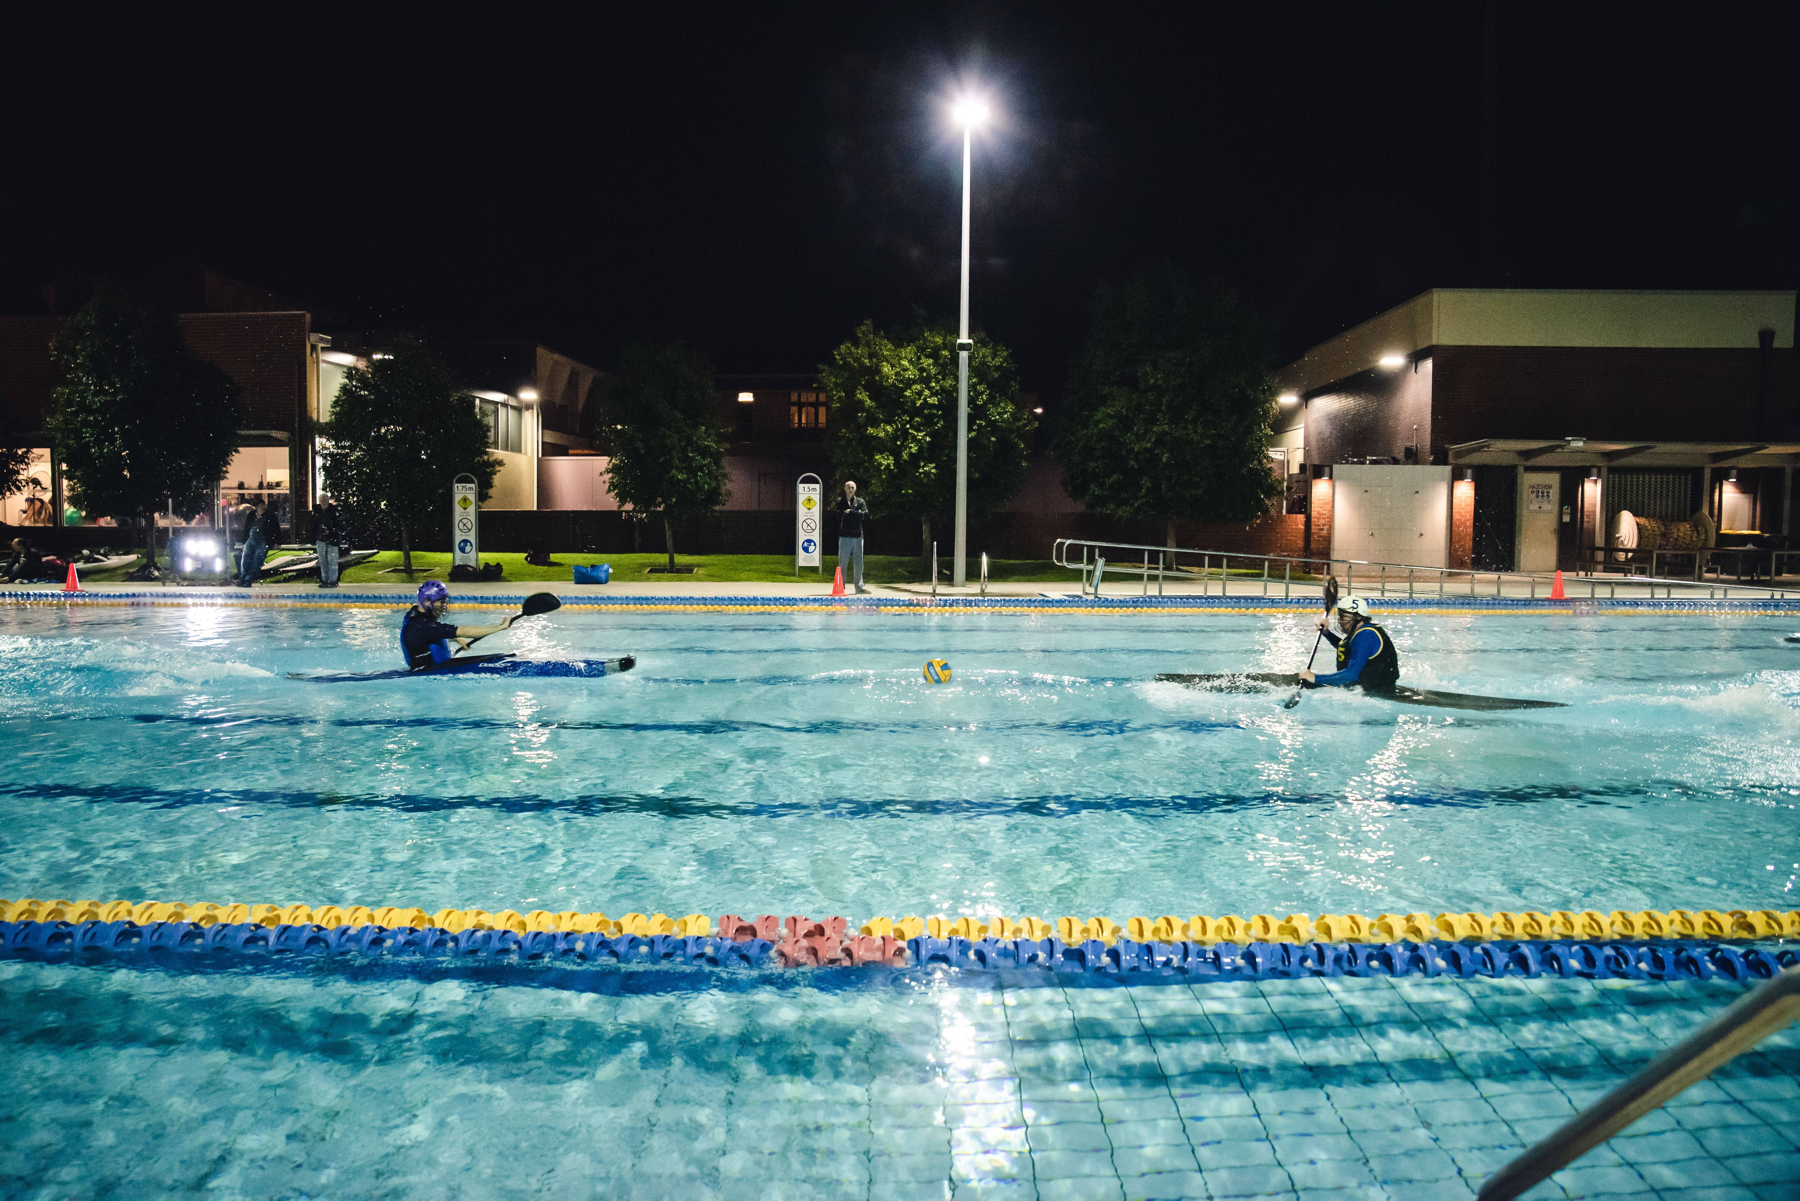

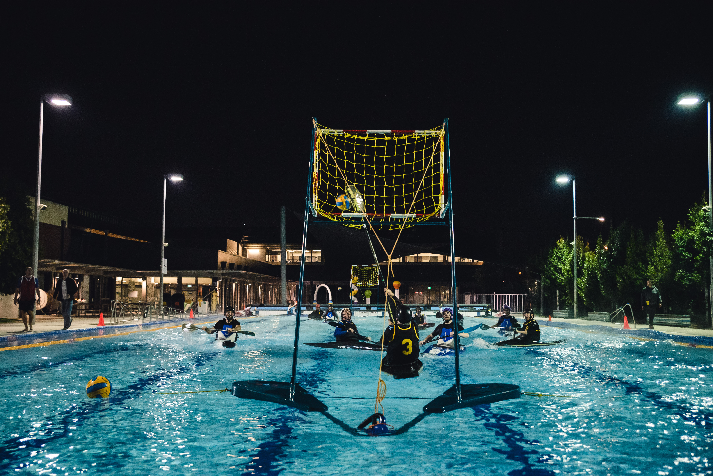
Photo: MM Focus Photography

This has been a big year for international competitions.
Firstly there were the World championships in Canada.
The Men’s Team finished 12th and Women’s Team finished 16th.
The Women’s Team included Brigit Doyle, Jennifer Stevens and Bec Jennings (Coach) with the Men’s Team including Matthew Perrin and Jay Burgess.
The Oceania Championships took place in Penrith, with New Zealand taking the championship.

Open Team - Michael Jarman, Jade Kerber.
Women’s Team - Brigit Doyle, Bec Jennings (as Coach)
U18 Team - Tom Waters, Andrew Waters (as Coach) U21 Team - James DuBose.
Over 30 Team - Andrew Waters, Michael Jarman, Rob McConnell
Over 45 Team - Paul Baker, Rob McConnell

Australian Championships in Penrith
Final results:
U18 – 6th
Masters – 4th
Open Women – 1st
Open – 8th
State Trophy Equal 4th

Our local competition has relocated to Brunswick Pool over the winter, and while competitor numbers have been down, it has been a fun competition on a Tuesday and Wednesday night.

Our next events that are coming up include Intervarsity Canoe Polo competition in Nagambie, interclub competitions, Summer Series (interstate competition) and Australian Championships.
Photo: MM Focus Photography

Hope to see everyone on the water soon.
Dale Tomlinson

Sprint Committee
Rowan Doyle

Paddle Victoria Sprint has had a year of building, change and delivery –re-growing Victoria as a sprint paddling state in addition to our capabilities in other disciplines. This has been made possible by a dedicated and passionate Sprint Committee working with the small core of Victorian sprint athletes, coaches and parents.
During 2018-19 we delivered two major events: the Victorian Sprint Championships and the Schools Championships, together with supporting local events: the Bendigo Sprint Cup and the Fairfield Spring Race. The Marathon committee also delivered a Long Distance Sprint event at Nagambie. Good numbers of Victorian sprint athletes competed at GP1 and GP2, but we were unfortunately unable to send a significant team across to Perth for the National Championships. The 3 Victorian athletes who did participate at Nationals did us proud – Briely Wight, Amanda Reynolds and Georgie Tonkin paddled well with AJ sweeping clean in all her events from 200 to 1000m, Briely reaching the finals in most events and winning the 5000m U18 women’s K1 and Georgie doing well in the 200s in particular: 3rd in the B final open women’s K1 and 5th in the final K2.

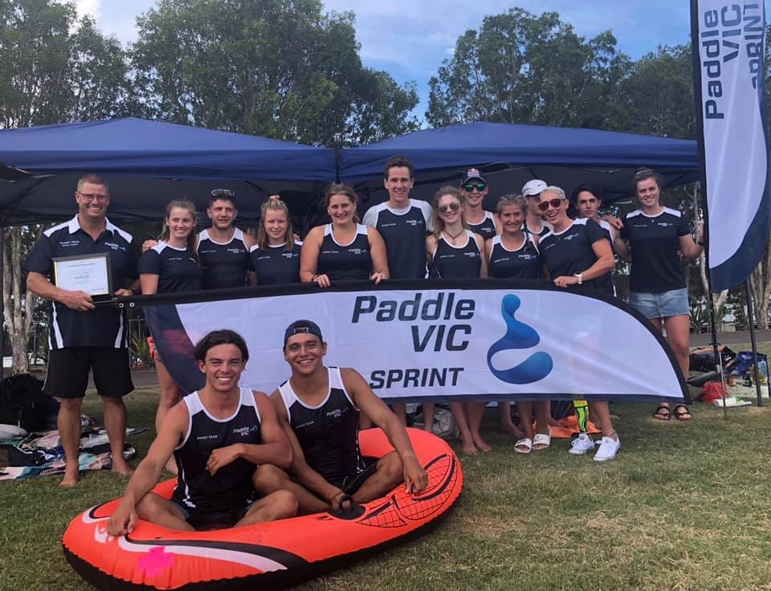

The sprint committee worked with Paddle Australia representatives to introduce PA’s “Regattas” system to help run the two major events, having used Webscorer previously. Using a new system for the first time is always challenging, but we successfully delivered the two events on time – and with results being published to the web continuously throughout the event days, which was a great step forward. The committee really appreciates the support of the many volunteers at these events – from the teams in the control tower, those on the water in rescue boats, the starters, marshals and runners who made the days possible.

The sprint committee also brought new sponsors on board: Swivs locker, AFI and McGain Group, which enabled us to provide new uniforms to the Victorian Sprint team, helping to create a real team coherence at the major interstate competitions. We now also have sprint banners and a marquee for use at regattas.

A suite of new documents – procedures, forms etc – was written to support the Victorian team to participate in major competitions and to support the committee in delivering events. Our communications team has done a great job in promoting Victorian sprint, with regular newsletters, social media postings and keeping the sprint section of the PV website up to date. We are now using “Team App” to communicate with athletes prior to and during major events.

2018-19 saw a new sprint squad formed – initially operating out of FCC/INCC and PLCC – bringing surf paddlers from the Peninsula together with city paddlers. The squad is continuing to evolve, now training 2-3 times per week in 3 locations.
We ran a small strategic forum during the year to discuss how we take sprint to the next level in Victoria – and in particular how we develop and support our athletes better. To this end we are working on an overall Victorian coaching plan – watch this space!

The sprint finances are in good shape, running at a surplus and close to budget before the two Bunnings BBQs that we ran during the year were added in: these raised more than $2,000.
I would like to thank the committee members who have contributed so much over the past year: Georgina Wakim, Lawrie Chenoweth, Reka Abraham, Jon Ford, Tony Misson, Marg Buck, Neil Grierson, Gary Flanigan, John Mayne, Jenny Mayne and Hannah Scott. I’m looking forward to the incoming committee taking the work that we have set in motion and really delivering Victorian sprint in to the future.

Rowan Doyle
Chair, PV Sprint Committee, 2018-19

Photo: Liesl Woods

Slalom
Chris Runting
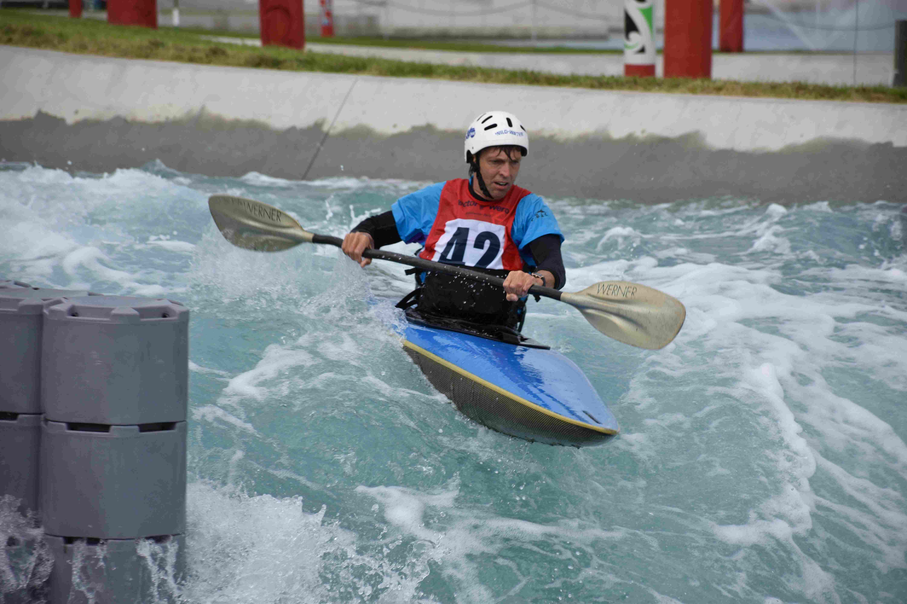

Overview
The Canoe Kayak Slalom Discipline in Victoria continues to be active with solid support from paddlers and many volunteers. The major highlight of the year was hosting the 2019 Australian Juniors Canoe Kayak Slalom and the 2019 Australian Canoe Kayak Slalom Masters Championships on the Goulburn River near Eildon over the 14th-20th January 2019.
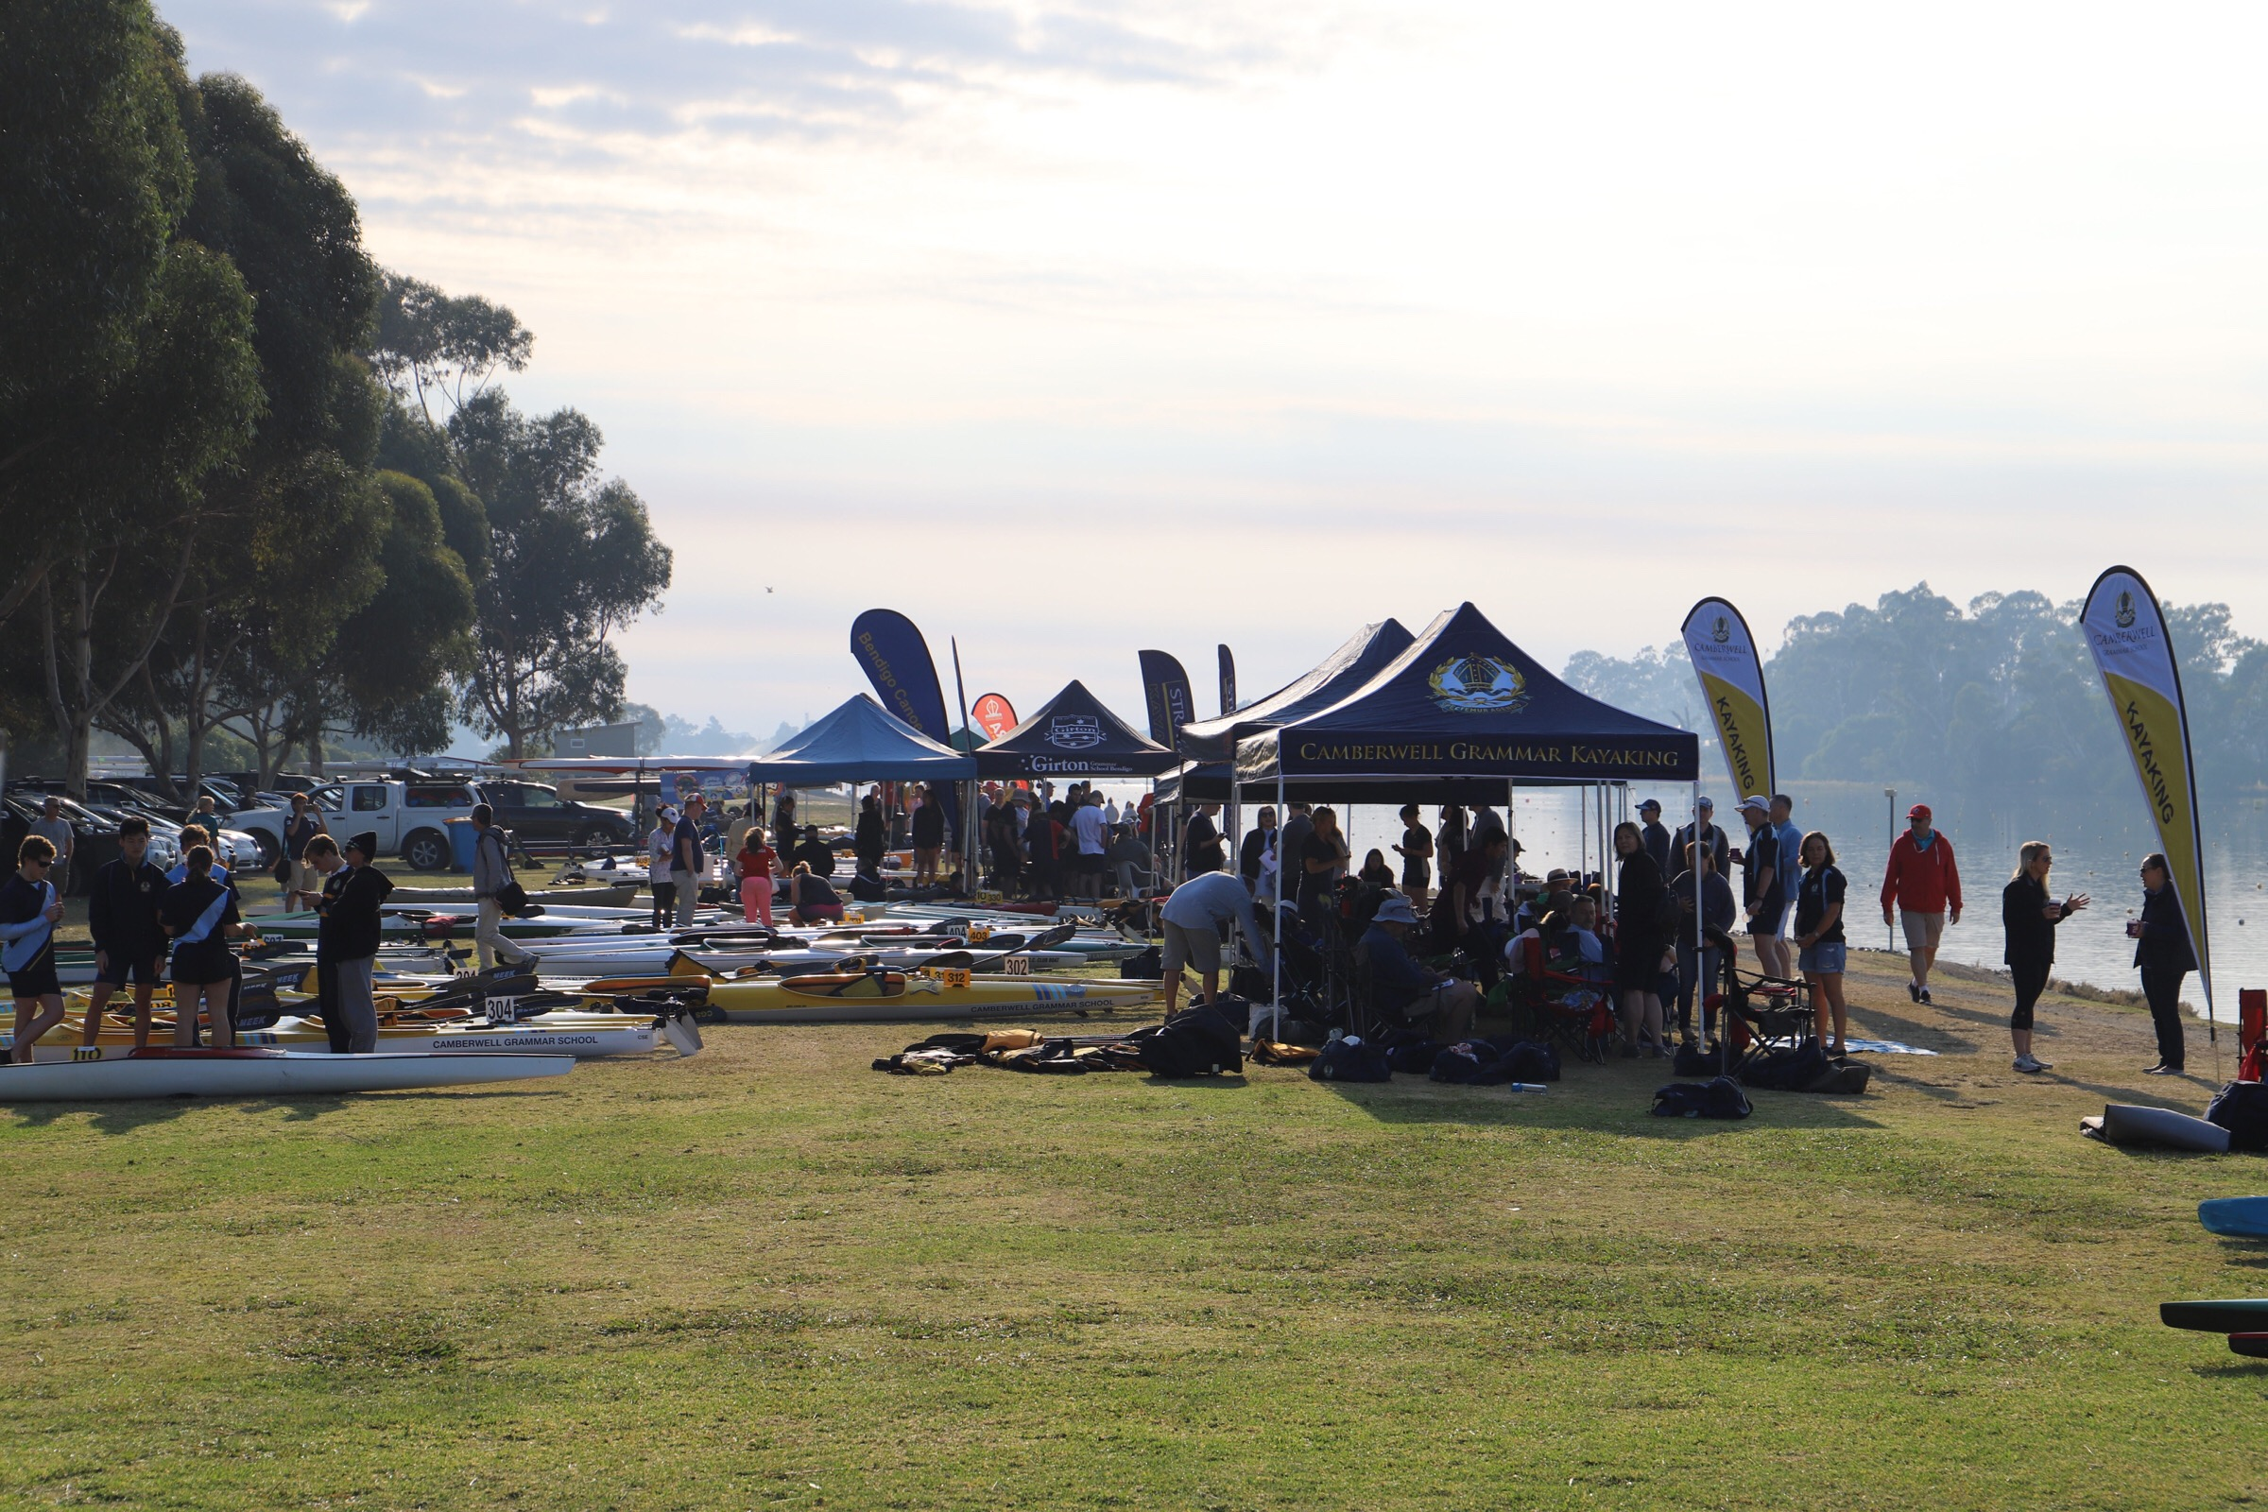
At the national level, significant numbers of Victorian paddlers, particularly at the junior level, continue to be selected in national training squads and teams. A national training camp was held over the 24th-26th November 2018 at the Goulburn River, Eildon in conjunction the Country Series Race 3. The event was attended by approximately 65 athletes with coaches and paddlers from West Australia, NSW and Tasmania. A number of Training camps were organized by Victorian slalom clubs (CPRT and MCC) at the Penrith NSW Whitewater Slalom course.

At the local level, there has been a continuation of the trend to lower numbers of competitors participating in the Yarra Series and Country Series Races. It remains a primary focus of the Slalom Technical Committee (STC) to reverse this trend and explore opportunities to enable more people to be involved in the sport and retain the participation of those currently involved.

Over the past few years the Country Series of slalom races has been compromised by low river levels coinciding with scheduled events leading to a many of the events being cancelled. The STC is working to reinvigorate the Country Series.

Critical works to improve the rapid at the Goulburn River and make it safe for the Australian Juniors and Masters events were successfully completed. There is the potential to improve the rapid with additional works. At Finns Reserve, Melbourne Water completed works to improve river access. Proposed works at the Fitzsimmons Lane slalom site by Melbourne Water in conjunction with Manningham and Nillumbik Councils remains in the planning stage due to funding and design issues. The Dights Falls rapid remains an underutilized asset as minimal re-instatement works to the rapid would allow it to be a quality slalom training and racing venue in the heart of Melbourne which could operate with natural flows for most of the year. Victoria continues to lose many of its elite paddlers to NSW as the need to train regularly on a course like the Penrith Whitewater Stadium is a prerequisite to make it on to an Australian team. The lack of such a facility in Victoria is a major impediment to the development of the sport.

The SiWi race timing, scoring and compiling system continues to be utilized for all significant races in Victoria and the number of officials competent in its use continues to increase. A successful race officials training day was held in May to introduce and train officials in the use of SiWi and other race official skills.

The members on the STC have remained the same with Russell Bassett stepping down as chair in February 2019 but remaining on the committee. Chris Runting has taken over the role as chair.

Slalom Races
The primary focus of the STC was to continue to provide a high-quality racing experience for all levels of competitors and to foster the development of junior paddlers and increase the number of skilled volunteers to officiate at races.

Yarra and Country Series
The Yarra Series continues to be a great introduction to slalom competition for the new and younger paddlers in close proximity to Melbourne. The Country Series, when the rivers flow, provides an opportunity for paddling on more challenging rivers such as the Big and King Rivers.

Victorian Championships
The Victorian Championships were held on the Goulburn River at Eildon on the 2nd and 3rd December 2018. There were 53 competitors, 40 males and 13 females. When compared to the number of entries at the 2014 Vic Championships the number of male paddlers has declined slightly by 6 and the number of female paddlers has remained the same.
This event, along with the results from the Country Series 3 race were used to select the Victorian Team who competed for the States Trophy at the Senior Australian Championships at Bradys Lake, Tasmania and the Junior Australian Championships at The Goulburn River, Eildon, Victoria. The team was:

Womens K1
Senior Team | Dita Pahl | Zoe Lau | Eliza Singleton
Junior Team | Claire Tonkin | Aby Collins | Sarah Crosbee

Womens C1
Senior Team | Madison Wilson
Junior Team | Georgie O’Callaghan | Kate Moorhen | Emile McKenna

Mens K1
Senior Team | Warwick Draper | Aiden O’Callaghan | Tristan Carter
Junior Team | Josh Montalto | Ryan Hughes | Ben Little
Cadets | James Stamp | Tyler Lewellin | Charlie Shamieh

Mens C1
Senior Team | Kaylen Bassett | Lachlan Bassett | Robert Janiszewski
Junior Team | Mark Crosbee | Ben Ross | Luke Anderson
Cadets | Archie Nelson | Lucas Del Brocco | Seth Hill

Mens C2
Junior Team | D Shamieh  B Mclaughlan | S Montalto  K Crunkhorn | C Flowers  T Ladson

Mixed C2
Junior Team | A Berryman/  R Galea

Victorian Schools Championships September 2018
The 2018 Victorian Schools Championships were held at Fitzsimons Lane, Templestowe on the 9th September 2018. There were 61 competitors, 43 males and 18 females. 17 different schools were represented. The school with the most competitors was Ivanhoe Grammar School with 30 participants.

2019 Australian Juniors Canoe Kayak Slalom
2019 Australian Canoe Kayak Slalom Masters Championships

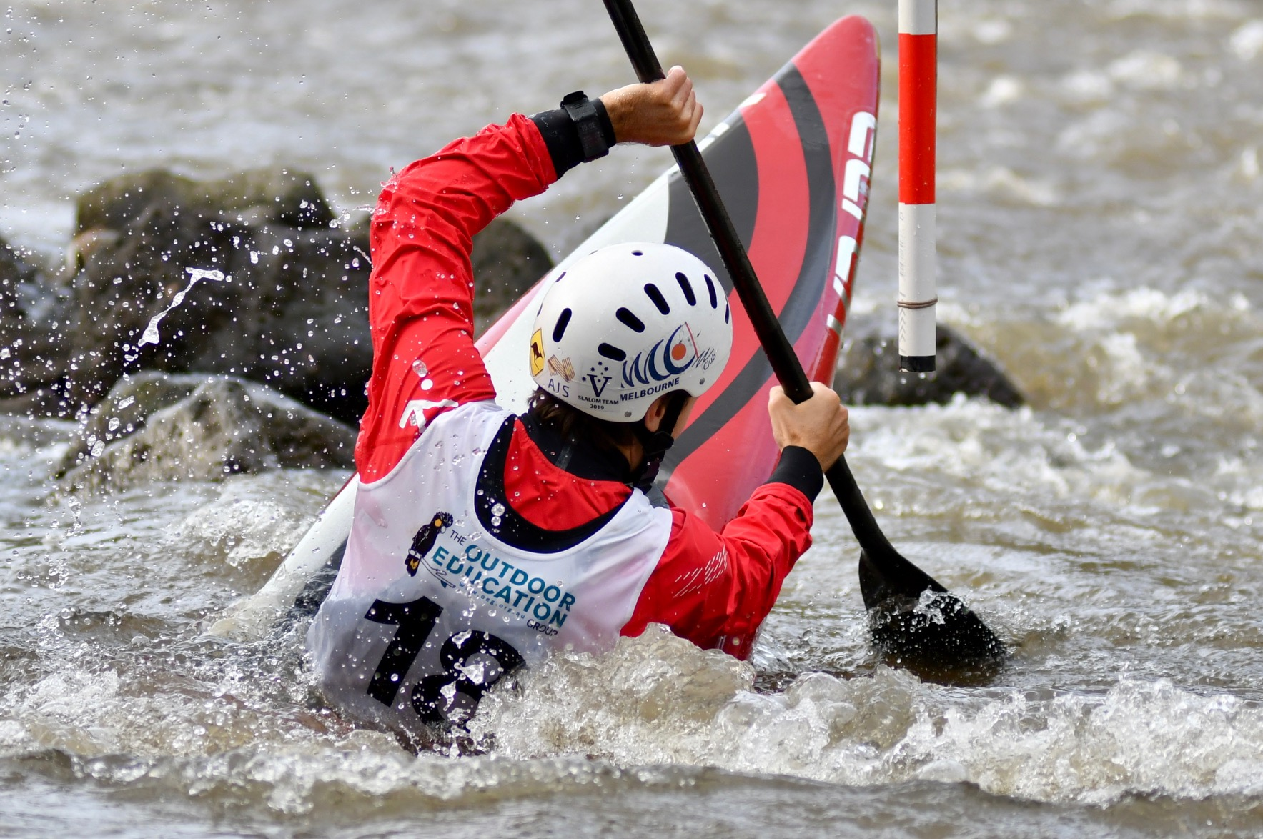
These events were run by the STC on behalf of Paddle Australia on the Goulburn River, Eildon over the 14th-20th January 2019.

This was the first time the events were held in this format. In previous years the junior’s event was held as the Australians Schools Championships in conjunction with the Australian Championships. It was also the first time a specific event for Masters Paddlers (35+ years of age) was held. This format proved to be successful and generally popular. A number of important lessons were learnt and feedback was supplied by the STC to Paddle Australia to improve future events. Paddle Tasmania will host these events in January 2020.
A total of 116 athletes entered the event, 31 female and 77 male, with many paddlers coming from Victoria. Of the total number of paddlers, 83% were in the junior age group (18 years and under) and 36% were female.

The following table provides the number of individual entrants to the Nationals events, by state/country, gender and age group.

State | Athletes  Per state | Gender | Athletes | Junior | Masters | Total
NSW |  | F | 6 | 6 |  | 6
NSW |  | M | 11 | 7 | 4 | 11
ACT |  | M | 2 | 2 |  | 2
TAS |  | F | 1 | 1 |  | 1
Tas |  | M | 6 | 4 | 2 | 6
VIC |  | F | 21 | 19 | 2 | 21
VIC |  | M | 52 | 45 | 7 | 52
WA |  | F | 1 | 1 | 0 | 1
WA |  | M | 9 | 6 | 3 | 9
Total |  |  | 109 | 91 | 18 | 109

A Judges course was run during the event, coaching clinics were also conducted during and prior to the event and a First Aid Course was run for Volunteers & Coaches.

The Victorian State Government provided significant funding to support this event and their assistance is greatly appreciated and contributed to making the event a success.

Photo: Andrew Stamp
Victorians at the Junior/Under 23 World Championships in Ivrea, Italy, July 2018

The following athletes and officials from Victoria were selected to the Australian Junior Team and participated at the Junior/Under 23 World Championships in Ivrea, Italy, July 2018:
Jnr K1M- Joshua Montalto (46th/83)
Jnr K1M- Bradley McLaughlan (42nd/83)
Jnr C1M- Robert Janiszewski (20th/56, Qualified for the Semi-Final)
Coach- Warwick Draper
Team Leader- Laura Montalto

National Development Squad (NSD) 2019

This is part of the Paddle Australia Slalom Pathways program. For athletes to be selected to the squad they had to perform well at the Canoe Slalom Junior Nationals and at a training camp run at Penrith in January 2019. The camp included physical testing and training sessions where athletes were assessed on their whitewater and slalom skills. The selected athletes get the opportunity to take part in training camps around Australia with national coaches and were able to be selected for the tour to New Zealand over the Easter 2019 period.

The Victorians selected to the squad are:
Mark Crosbee
Daniel Shamieh
Keanu Crunkhorn
Brad McLaughlan
Kate Moorhen
Ben Little
Seb Montalto
Abby Collins
Ryan Hughes
Ben Ross
Josh Montalto
Georgie O’Callaghan

The Canoe Slalom Development Squad from Victoria selected for the New Zealand tour over Easter 2019 were:
Keanu Crunkhorn
Kate Moorhen
Ben Little
Seb Montalto
Abby Collins
Ben Ross
Josh Montalto
Georgie O’Callaghan
Coach: Christian Fabris
Team Leader: Jill Bassett

Victorians Selected For the Junior/Under 23 World Championships in Krakow, Poland, July 2019
Tristan Carter U23 C1
Brad McLaughlan Junior K1
Josh Montalto Junior K1
Daniel Shamieh Junior C1
Mark Crosbee Junior C1

Victorians Selected For the World Cup Squad 2019
There were no Victorians selected for this squad.

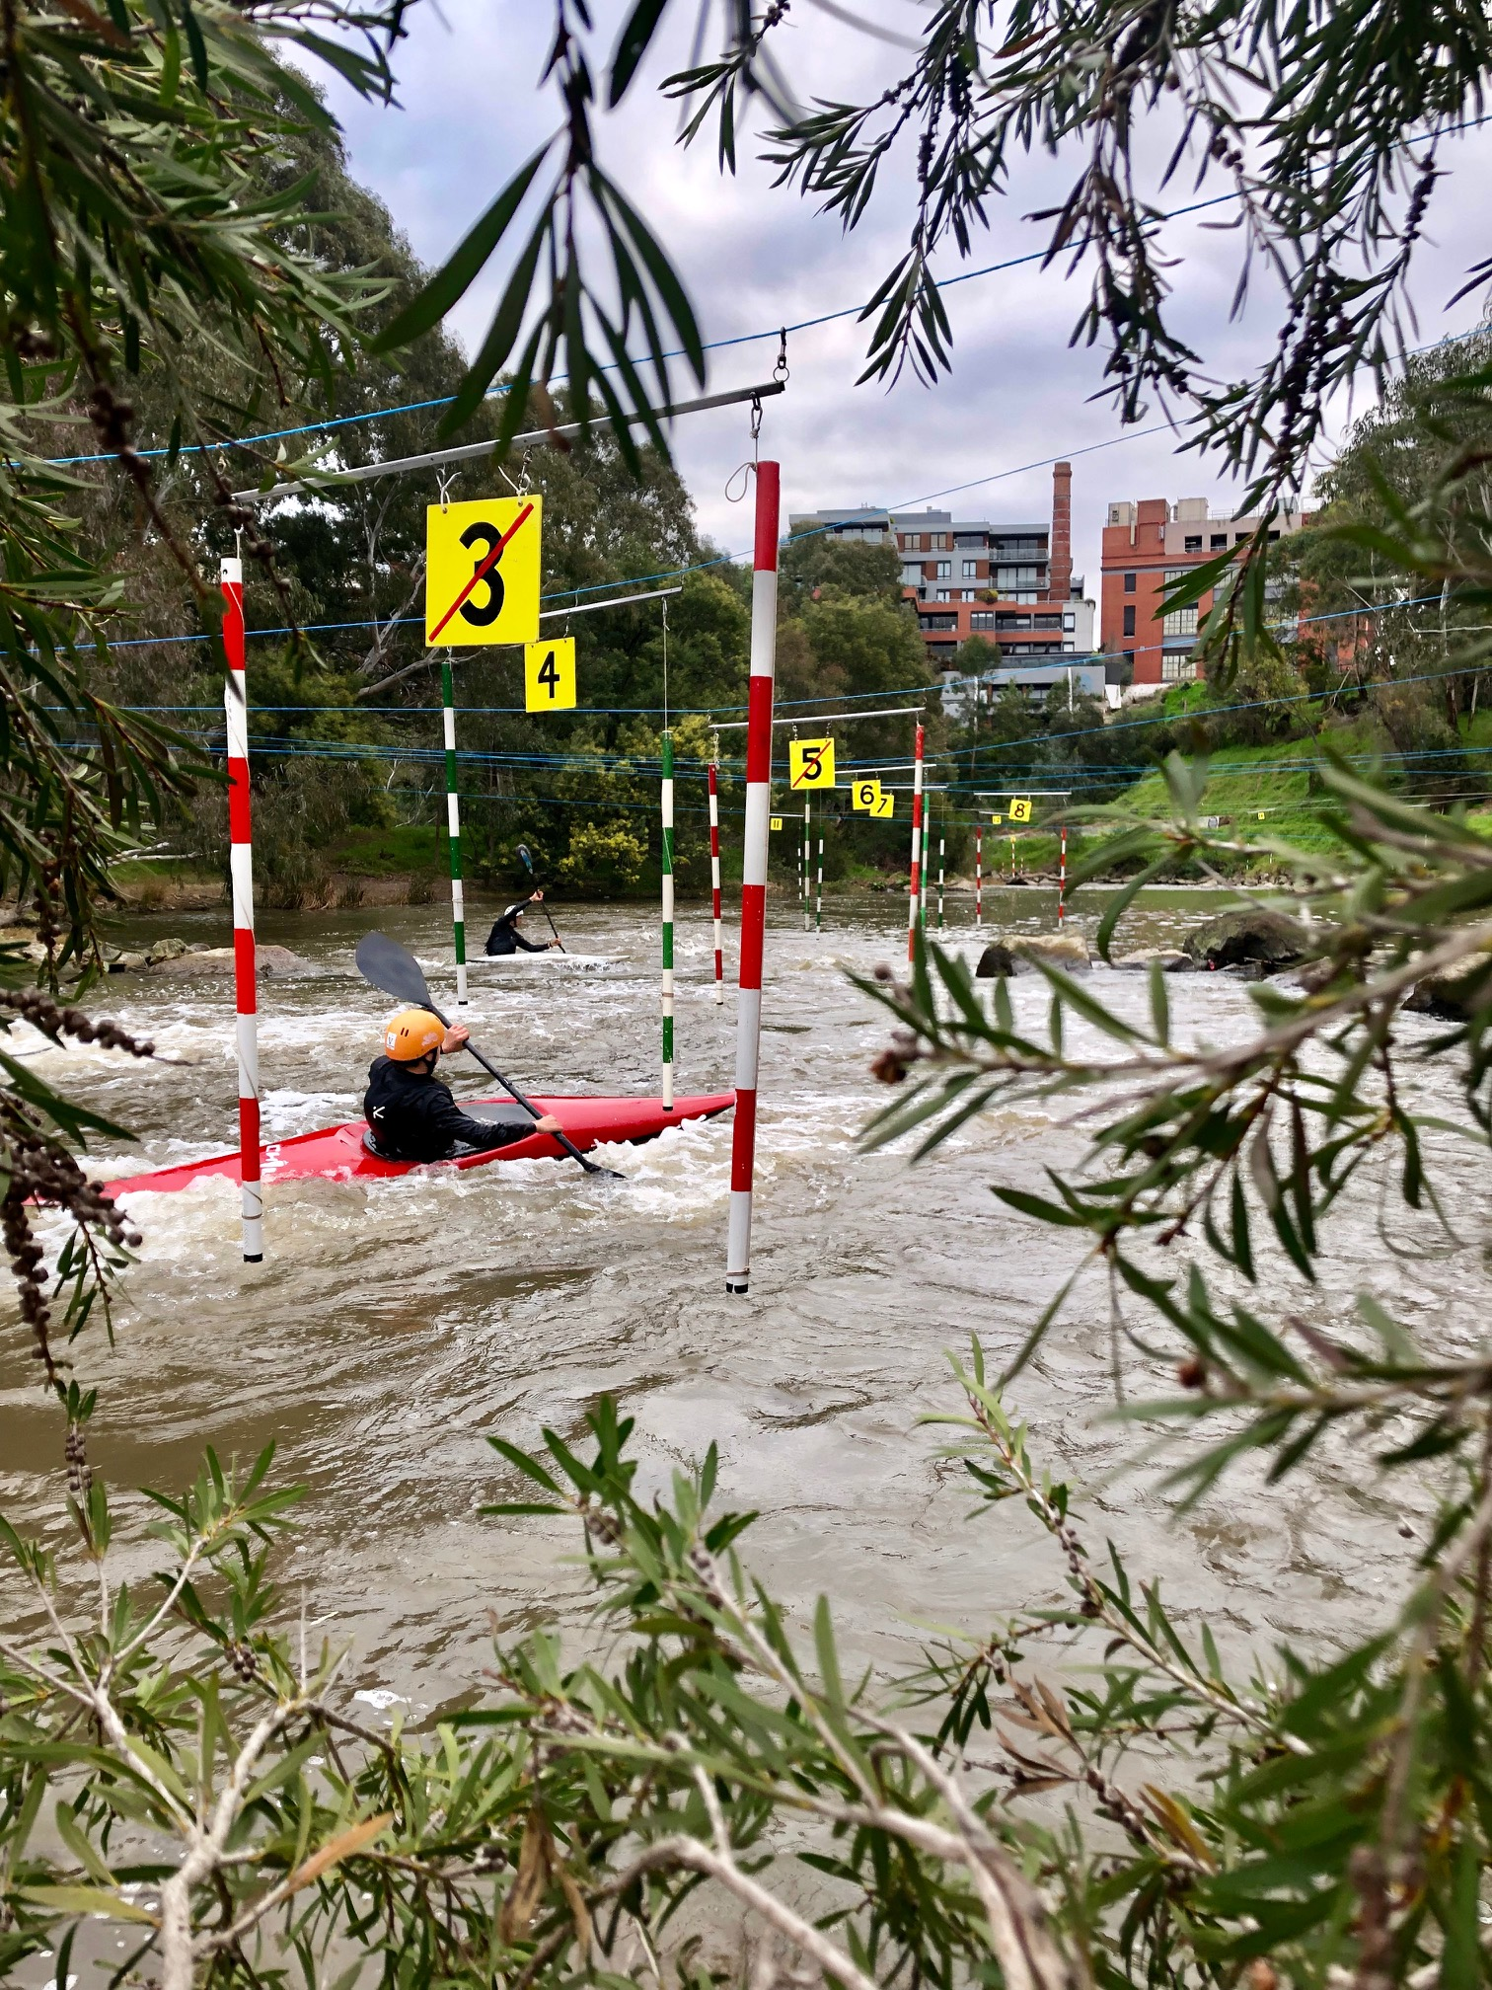

Photo: Andrew Stamp

Australian Open and Oceania Championships, Penrith, February 2019
A number of Victorian Race Officials helped run these events by taking a lead role to run the “SiWi Data” timing, scoring and compilation system. SiWi Data is the timing and scoring system used to time and score canoe slalom races at Olympic and International Level (ICF World Cup and ECA Events) and its use is a pre-requisite to host an ICF event such as these. A key objective of the STC is to improve the knowledge and expertise around using SiWi, increase its use where practical and train as many race officials as possible to be able to operate it. Maintaining and growing the number of race officials with these skills is essential to Australia being able to continue hosting international events.

Acknowledgements
I would like to thank the members of the STC who all make such huge contribution. I have been fortunate to be part of a committee with such a diverse and complementary skill set whose expertise and experience has made my transition to chair a positive experience. I am also appreciative that Russell Bassett has remained on the committee and assisted with the transition and continues to provide his expertise in running races. Thanks are also due to those volunteers who step up whenever required, be it setting up courses, pulling them down, judging and officiating at races, rescue or coaching, often in challenging conditions. Their efforts are often unacknowledged and unseen but are greatly appreciated and essential to being able to run slalom races in Victoria.
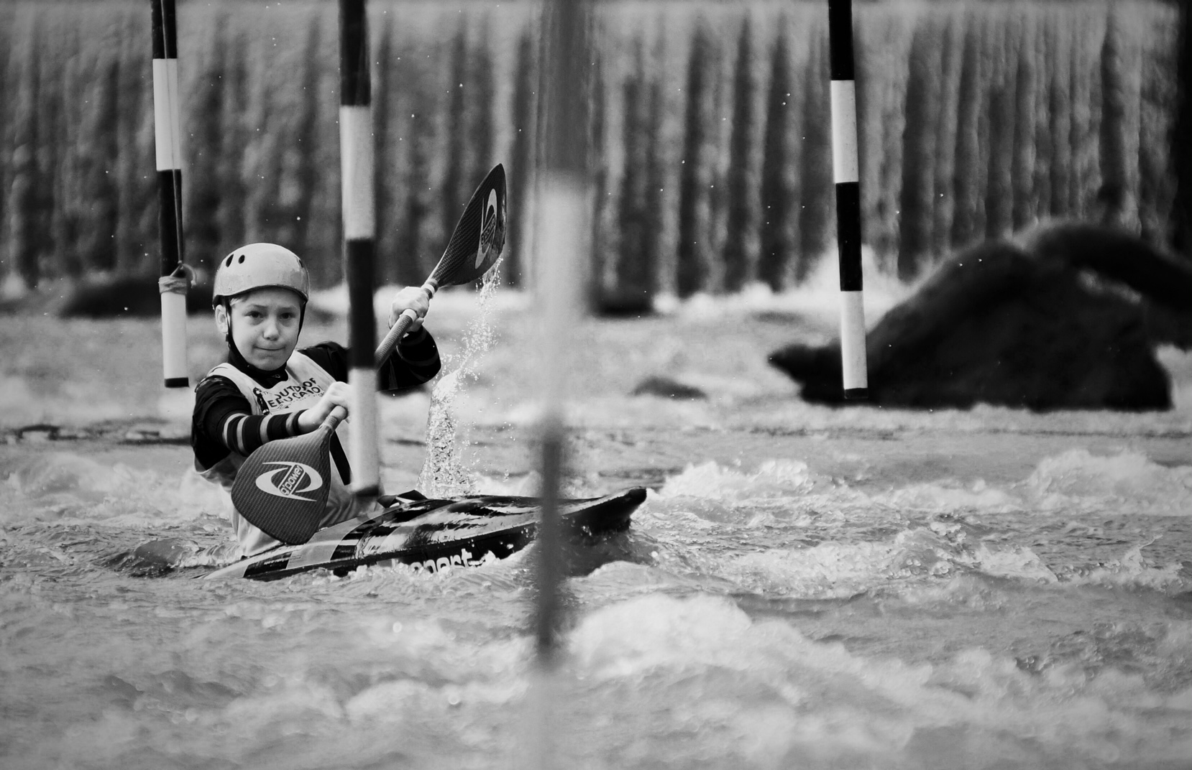
Photo: Andrew Stamp

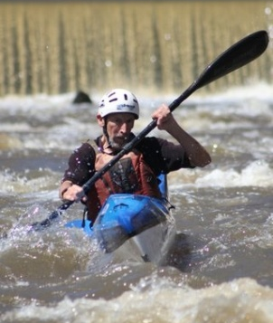

Wildwater
Chris Wharton

The last 12 months have been a busy time for Victorian Wildwater with increased participation and a growing group of keen young paddlers. The National titles were held on the Mersey River in Tasmania and Victoria had its biggest participation ever with a total of 23 paddlers. The Mersey is a big step up from the Goulburn River and the juniors really improved. The results were also very pleasing with Victoria featuring prominently on the results and many of juniors making selection percentage.

Victorian Downriver Paddlers at Mersey River Jan 2019 National Titles

Results from the Junior and U23 World Championship were better than the previous time. The sprint times were more competitive than the classic race with the best sprint times about 3% off the pace compared to 7.5% for the classic. An overview of the results is given below.
The senior results at the World Cup Treignac France 2019 were also pleasing with the C2 of Kaylen and Lachlan Bassett placing 6 and the C2 of Lewis Wylie and Ben Strmecki placing 9. Robert Janizewski was 12th in C1 and Maddie Wilson continued her form from the U23 to place 5 in the WC1.

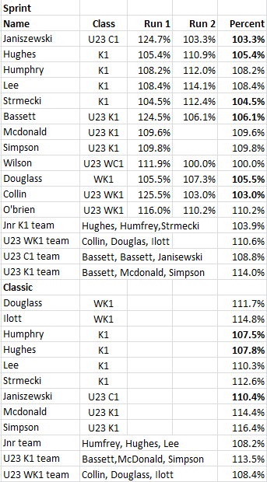
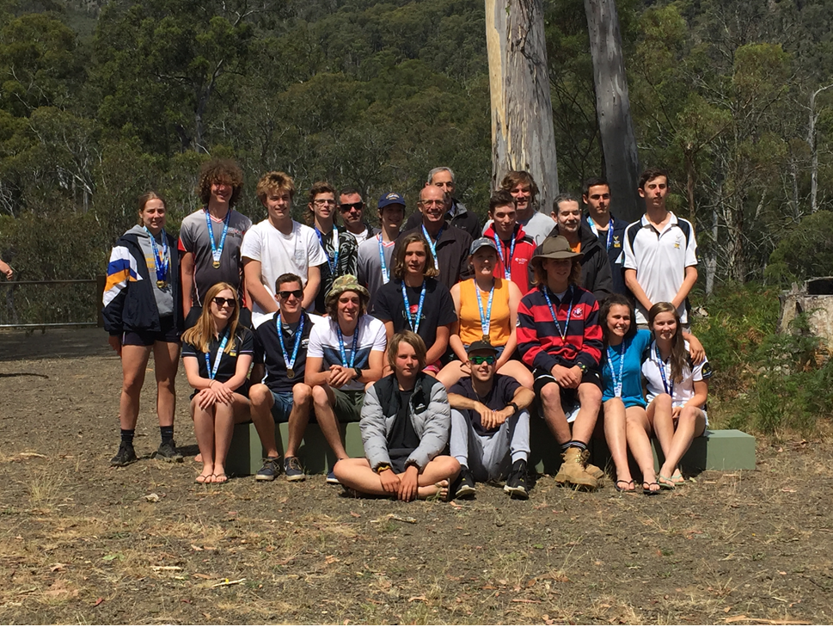

The Wildwater committee has been bolstered with an increased number of keen supporters. Currently comprises: Secretary Lyne Strmecki, general committee: Roger Douglass, Warren Elms, Roy Farrance, Damien Guthrie, Neville Humphry, Wes Hurrey, Tony Misson and Dita Pahl.

Chris Wharton
Chair person

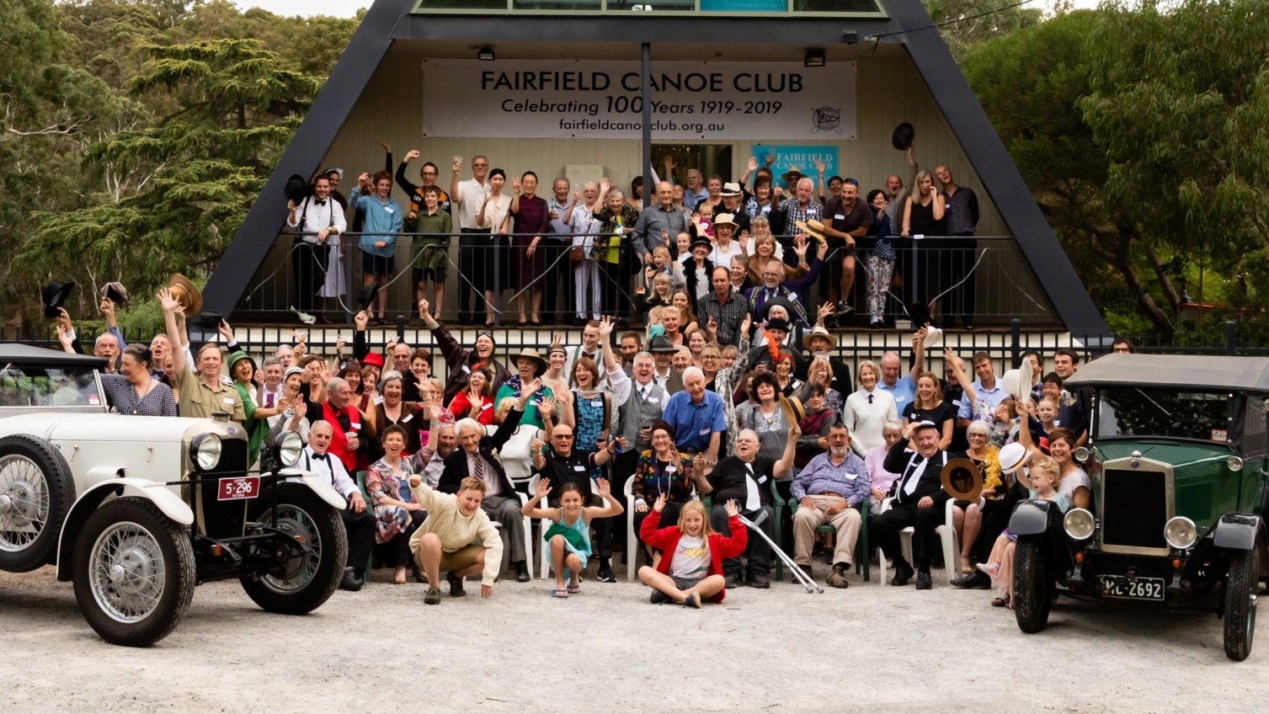
FAIRFIELD CANOE CLUB CELEBRATES 100 YEARS IN TWENTIES STYLE

On Sunday 7 April 2019 Fairfield Canoe Club (FCC) celebrated the centenary of its foundation with a Roaring Twenties Cocktail Party. Flapper dresses, feathered headbands, braces, fedoras and spats were on full display as club members past and present jitterbugged and sipped on Prohibition-Style mocktails and Champagne.

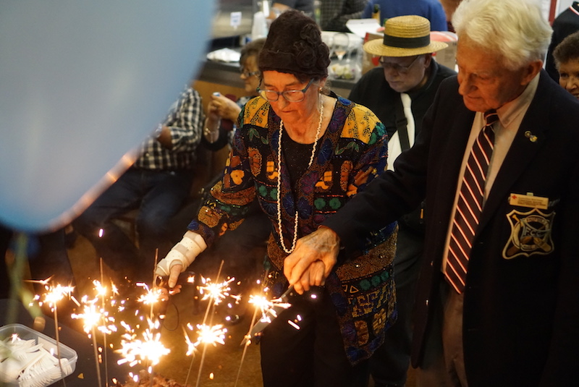
City of Yarra Mayor, Cr Danae Bosler, honoured the occasion with the presentation of a certificate recognising the club’s contribution to the City of Yarra as the oldest continuous canoe club in Australia.

Partygoers clustered around the display of more than 100 photographs showcasing the club’s history, events and people, while a number of beautiful restored antique canoes and kayaks lent a wonderful atmosphere to the 1980’s A-frame clubhouse.
Located on the Yarra River, in an idyllic part of Alphington overlooking Yarra Bend Park, the

Fairfield Canoe Club is one of the few canoe clubs in Australia to have private access to a river. The peace
of the surrounds is punctuated by the gentle chiming of bellbirds and provides an unexpected haven from the busy Eastern Freeway and Lower Heidelberg Road only minutes away.

Life member and 1964 Tokyo Olympian Margaret Buck cuts the Centenary Cake with the aid of fellow life member Jonathon Mayne.
How did the Fairfield Canoe Club evolve?
Arthur Howard writes: “It seems that the war eased the class barriers as those that didn’t go to the war and the returned men got on very well together in this club (Boomerang Canoe Club), canoeing up river on picnics and to the “Ryver Brink Cafe” for meals and the popular Saturday Jazz nights, also canoe racing and novelty events that Edmund Cooke the Proprietor at Rudder Grange organized from time to time to entertain his cafe patrons. These Boomerang Canoe Club men liked to have a drink and started to bring it down to Rudder Grange, it was one of Cooke’s policies that no alcoholic drinks be on the premises, he asked the club members to mend their ways or take their canoes and leave. Fourteen decided to leave, packed their gear in to their canoes and paddled downstream to the Fairfield Park Boat House, known then as “Willow Dell”, where canoe storage was available. Within weeks of leaving

Rudder Grange they established a new club, the Fairfield Canoe Club on March 1919 this being their headquarters for several years.”
At “Willow Dell”, the FCC headquarters in Fairfield Park, they started interclub canoe racing and had their first canoe carnival, they also travelled to other clubs venues for club racing”.
In 1924, FCC purchased the riverfront block we still occupy today. A clubhouse was commenced in 1925 and completed three years later, built entirely by club members. This original building became very dilapidated and was demolished in 1981, to be replaced by the ‘A-frame’ building that you will all be familiar with today. This too, was largely constructed, slowly owing to cost constraints, by the club members.

Fairfield Canoe Club Today – One Hundred Years on
Should they paddle those 500 yards upstream from their first home at the Heidelberg Boathouse at Fairfield Park all those years ago, our founding paddlers of 1919 would be proud of what they would find at 9 The Esplanade, Alphington.
Fairfield Canoe Club has weathered numerous floods, World War 2, the Great Depression and a varying interest in the sport of canoeing/kayaking. Nine club members were Olympians with many national and state champions amongst our membership too. Today we have a strong club of 300 members (34% female) all of whom are shareholders in an Incorporated Co-Operative that is financially stable and housed in a first-rate Clubhouse. A club that has members ranging from eight to eighty years, and many club boats for all to share. A club that provides opportunities to pursue the full gamut of paddling endeavours, both competitive and social.
Our club lives on into the 21st Century!

Please visit our website for more history

https://fairfieldcanoeclub.org.au

and

https://fairfieldcanoeclub.org.au/club_photo_gallery/index.php?/category/centenary-party

to link to all of the photos of our celebration

NB. We look forward to all Paddle Victoria clubs attending our “FCC Centenary Canoe Carnival” on Sunday December 1st, 2019. This will be a 1920’s-themed team event for us to enjoy just before Christmas. More information in due course, but please enter into your club calendar today!

Ballarat Canoe Club

BALLARAT CANOE CLUB 1956 Olympic Kayak

- This double kayak was used by an unknown European team in Ballarat for the 1956 Olympics.
- It is a wooden Strauer from Denmark
- It was left with the Corden family who were rowers, hosting Olympians.
- The kayak hung from the roof of their hallway for many years, and parts were painted green.
- Eventually it was donated to the Ballarat Amateur Canoe Club, and was kept in storage by member Tim Blee who is a very knowledgeable kayak builder himself.
- He has moved it to the clubhouse at Lake Wendouree where it now resides.
- Tim presented the kayak at a club meeting and described in detail the design and construction of it and historical importance.
- Ballarat Club is very fortunate to have custody of such a significant piece of Ballarat and Olympic sporting history, and superb craft.

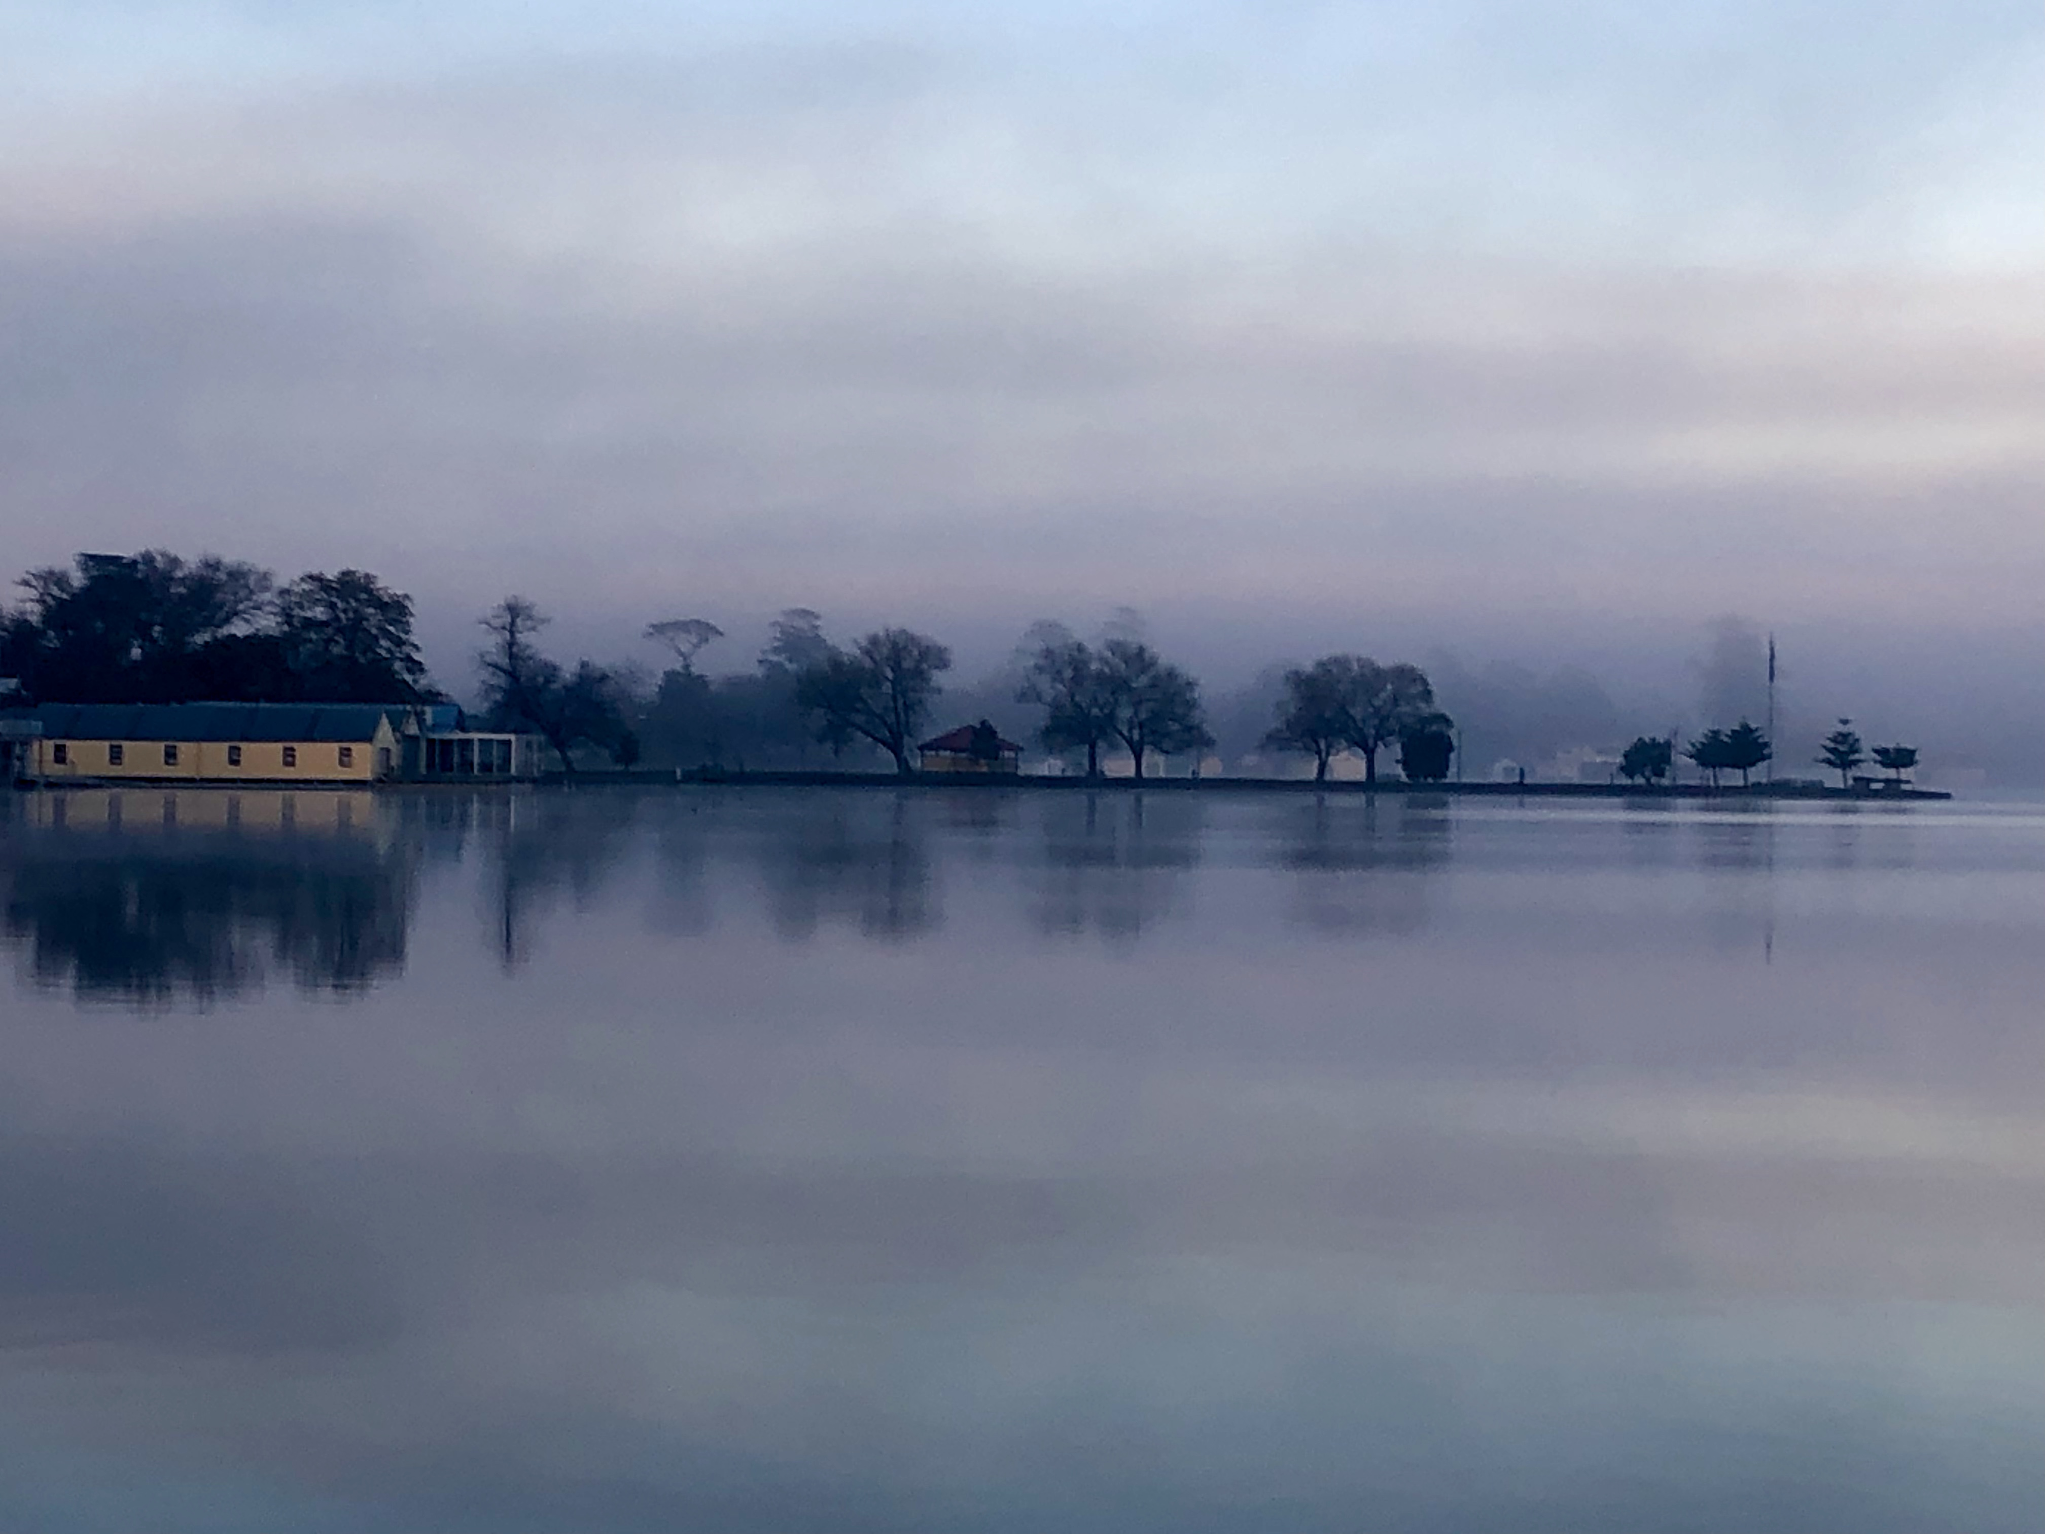
A stunning morning at Ballarat Canoe Club

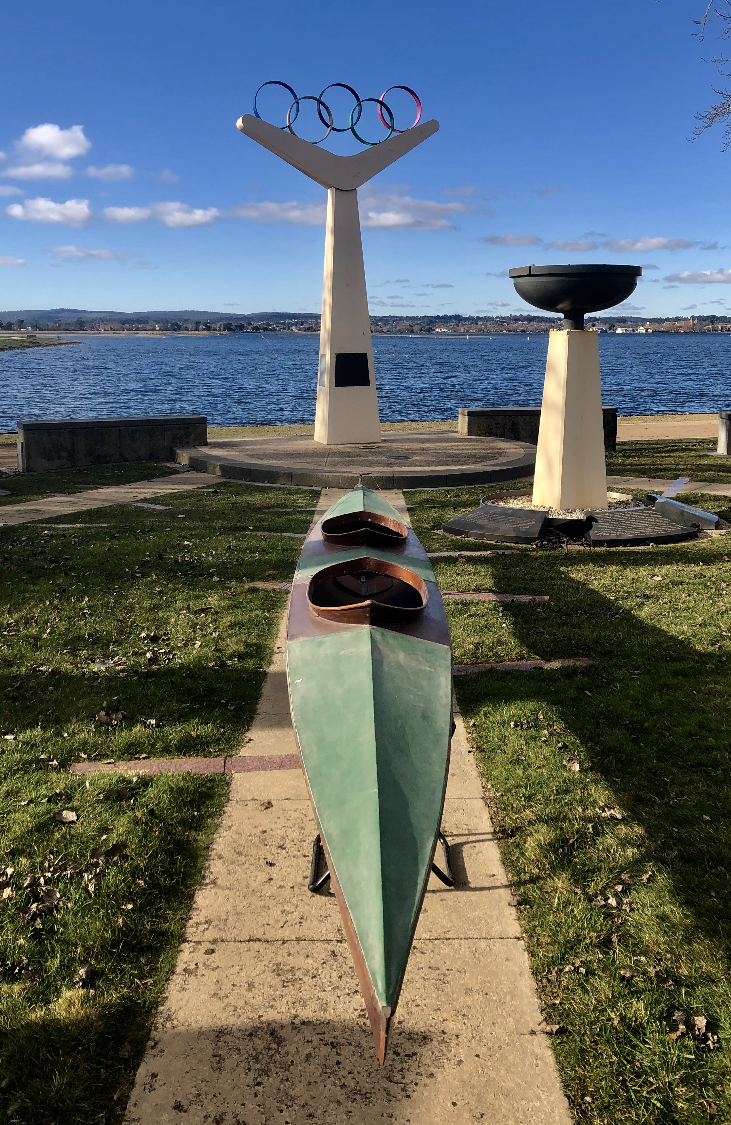

Whitehorse Canoe Club Turns 50
Whitehorse Canoe Club turns 50 years old this year, having originally been formed in November 1969, by brothers Trevor and Kevin Thiele and a collection of family members and friends. In those early days, many hours were spent making fibreglass boats from a mold, including a final overnight session finishing off the last ones needed for their first expedition to the Mitta Mitta. Fuelled by Stone's green ginger wine and jaffles, the intrepid early club members ran a number of Victorian rivers and rapids for the first time, typically with no prior knowledge of the river and conditions.
One of the most notable "firsts" of this early period was founding member Ian Richards, along with brother Peter Richards and friend Rod Harris, making the first known crossing of Bass Strait by kayak, in 1971. Other features of the early years include organising and running the first Victorian slalom championships on the Mitchell River in the early 1970s, and instigating the Barkly River Race, which morphed into the Whitehorse Bush Triathlon, an early Victorian multi-sport event. Trips that were established as regular entries in the club calendar, such as the Queen's Birthday weekend trip to the Mitchell River and the end-of-year expedition on the Snowy River, continue to the current day.
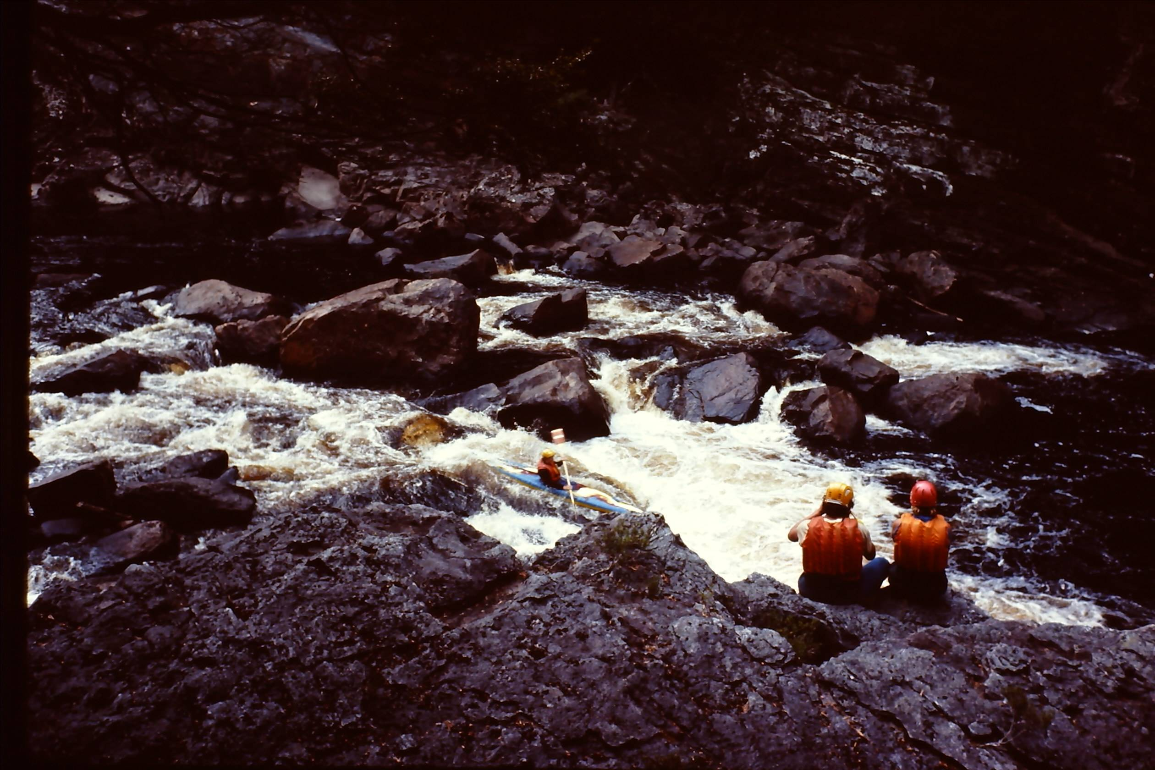

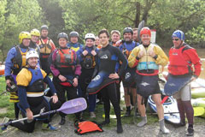

Whitehorse Canoe Club continues the whitewater adventuring spirit of its early members, although in the relative comfort of goretex, plastic boats, carbon-fibre paddles, and online guides to rivers and up-to-date river conditions. Still, excursions to farther flung reaches of the Nymboida, the Tully, and Tasmania and NZ have thrown up their share of adventures, including epic swims and even a boat being found on the Tasmanian coast months after being lost! The club is proud to have introduced so many people to the joys of kayaking in the Victorian bush over the past 50 years, and continues to support the development of recreational whitewater paddlers, young, older, and in-between!
-----
Whitehorse Canoe Club will be holding a commemorative event on Sunday November 24, from 11am onwards, at the Paddle Victoria Conference room at Westerfolds Park, serving lunch and nostalgia! Anyone welcome: please RSVP to linton.henderson@gmail.com if interested.
Lawrence Cavedon
President

Paddle Victoria

Roving Reporters Photo Competition

January, 2019 competition was by Isaac Johnson.
Photo: January in Warrnambool

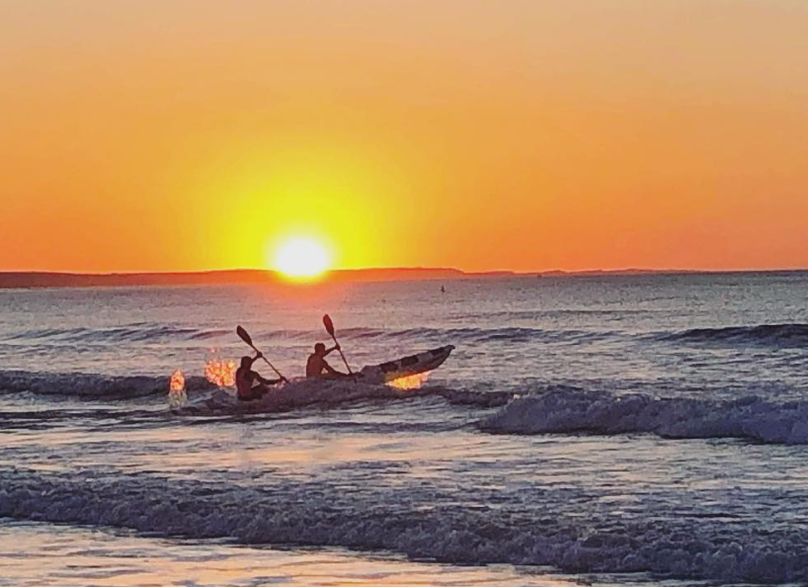

May, 2019 competition was by Dale Tomlinson
Photo: Brunswick baths canoe polo
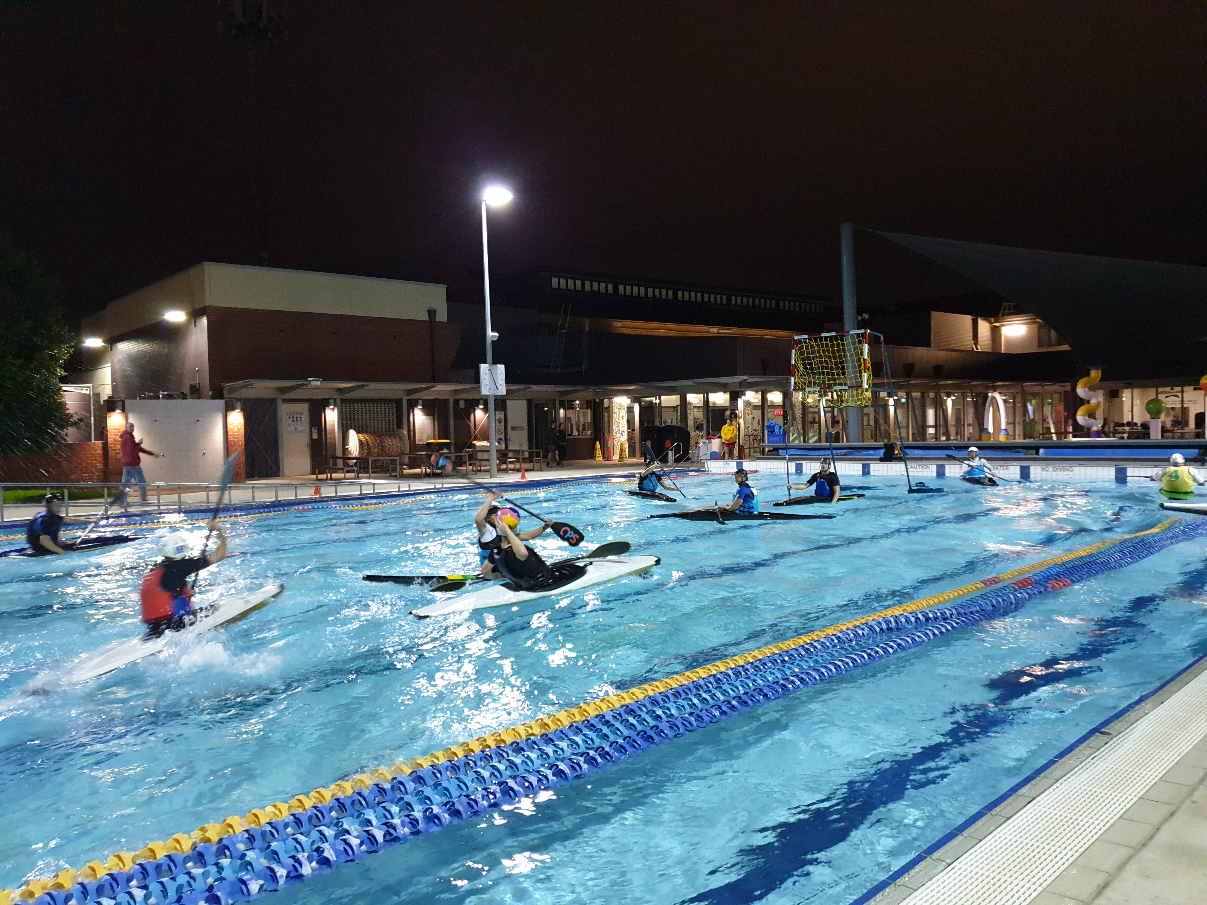

Acknowledgments


We acknowledge the support of our major
sponsors the Victorian Government through
Sport and Recreation Victoria and Vichealth,
Life Saving Victoria and Melbourne Water.
The local governments that support our clubs

at the grassroots level, thank you for your
financial support of our vision and our passion.




Next Section:

Audited Financial Statements

