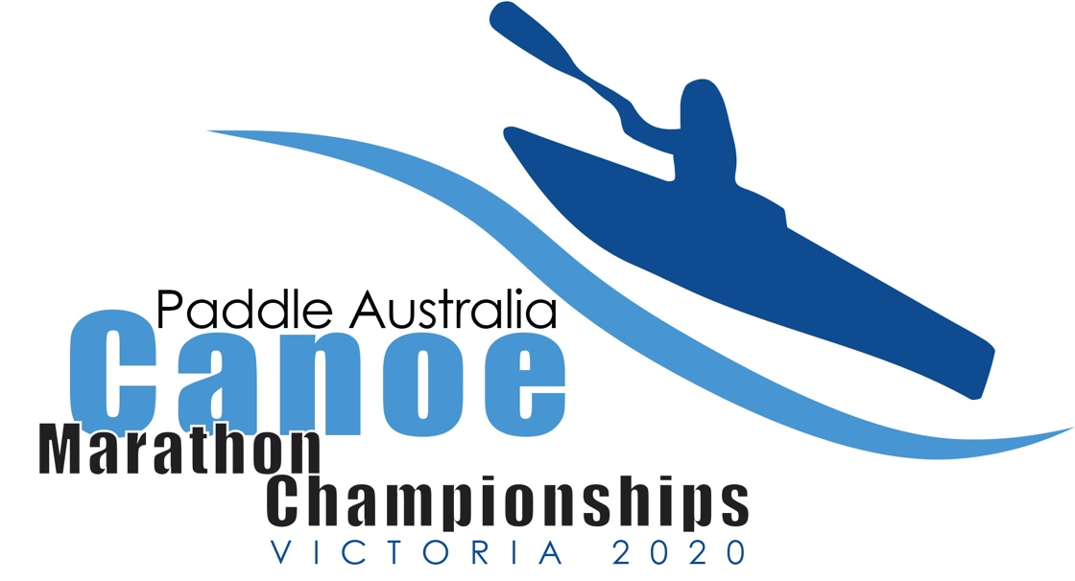
  - Issue 1
November 2019
The newsletter for the 2020 Paddle Australia Canoe Marathon Championships.
16 to 20 April 2020
Geelong, Victoria

Welcome

Paddle Australia, along with Paddle Victoria Marathon, is delighted to host the 2020 Paddle Australia Canoe Marathon Championships on the Barwon River in Geelong, Victoria from Thursday 16th – Sunday, 19th April 2020. The organising committee has worked hard to bring you a world class event, so please book early and enjoy.

Geelong
Geelong is Victoria's second largest city, located on Corio Bay, and within a short drive from popular beach-front communities on the Bellarine Peninsula as well as being the gateway to the famous Great Ocean Road, which begins just south of Geelong at Torquay.
The city offers visitors the chance to explore popular beach-front attractions such as Eastern Beach with its swimming enclosure, the Steampacket Gardens, dining options available on Cunningham Pier, and several coastal walks, dotted with collections of bollards depicting historic characters. Elegant architecture, colourful gardens and parks, and the backdrop of Corio Bay are all symbolic of what locals refer to as the "city by the bay".
Locations of interest for visitors include the National Wool Museum, the Old Geelong Gaol, the Botanic Gardens at Eastern Park, Geelong Museum of Motoring and Industry, and a number of other museums, galleries and historical buildings.

The Barwon River meanders through Geelong and its surrounding suburbs, fronted by a number of attractive parks and the scenic Buckley Falls in Fyansford. On its journey to the coast, the river flows through the wetlands of Lake Connewarre before entering Bass Strait at the twin towns of Barwon Heads and Ocean Grove.

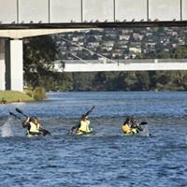
Geelong offers a large variety of accommodation to suit

How to Get to Geelong

Corio Bay Rowing Club is located in South Geelong on the banks of the Barwon River.

It is approximately:

85 km from Melbourne Airport

76 km from Melbourne (Southern Cross Station)

25 km from Avalon Airport

3 km from Geelong Railway Station

Geelong Accommodation
There is a range of accommodation options close to the event.
Accommodation | Distance | Contact
Colonial Lodge Motel, 57 Fyans St, Geelong | 400m | (03) 5223 2266
Kardinia Park Motel, 422 Latrobe Terrace, Newtown | 900m | (03) 5221 5188  www.kardiniaparkmotel.com.au
Barwon River Holiday Park, 153 Barrabool Rd, Belmont | 600m | 1800 657 955  barwonriverhp.com.au
Discovery Parks Geelong, 59 Barrabool Rd, Belmont | 2 km | (03) 5243 6225  discoveryholidayparks.com.au
Riverglen Holiday Park, 75 Barrabool Rd, Belmont | 2 km | (03) 5243 5505  riverglenhp.com.au
Championship Venue
Barwon Terrace, Geelong

Venue
The championships will be held on the Barwon River at the Corio Bay Rowing Club on Barwon Terrace.

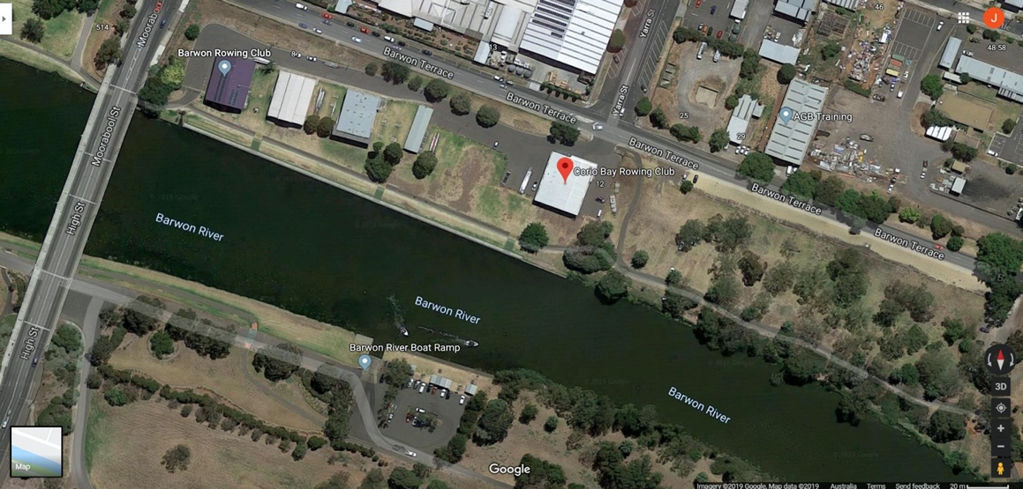

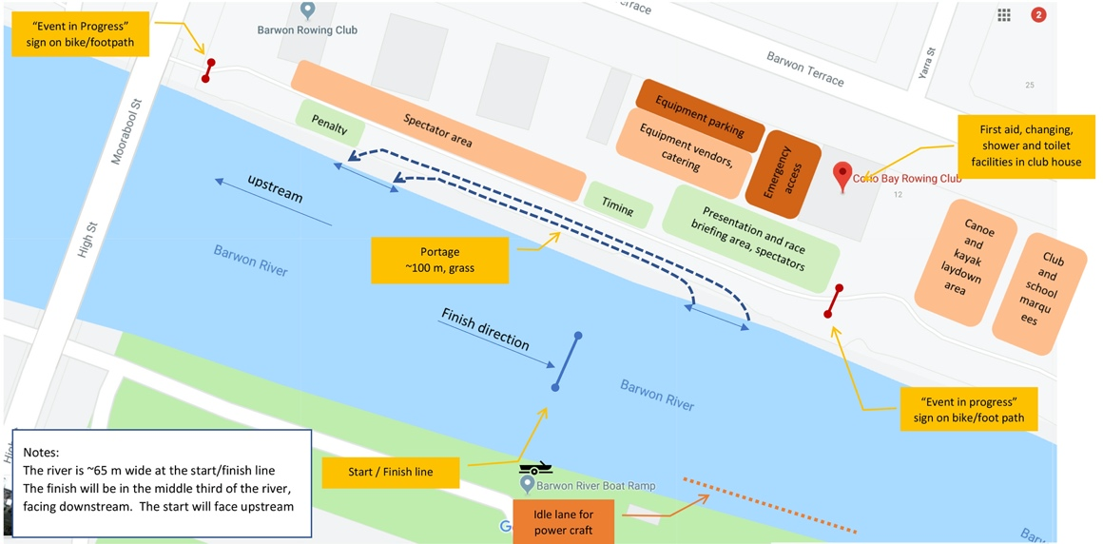Venue Layout

Course – Short
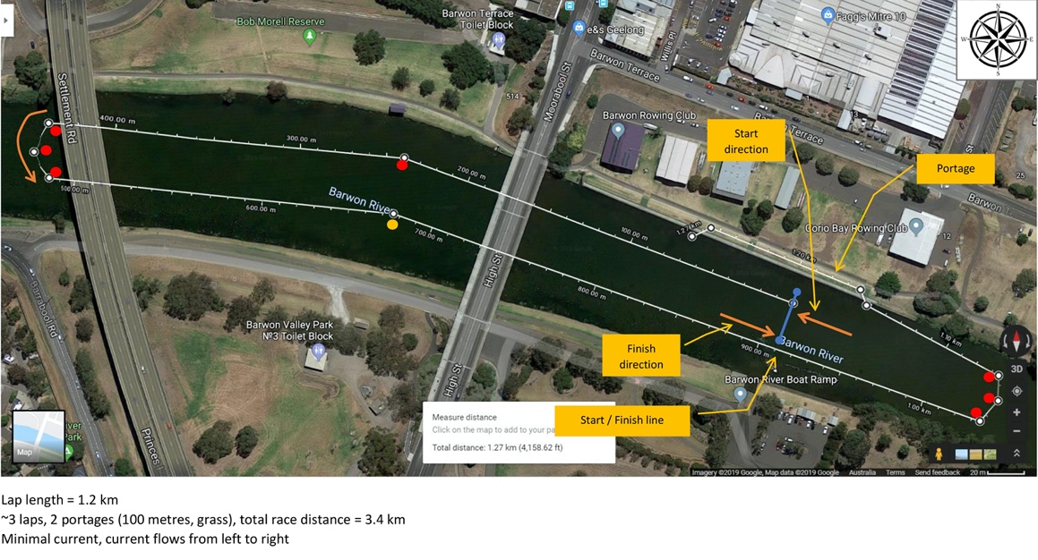
Entry and Program Information in next Newsletter

Course - Long
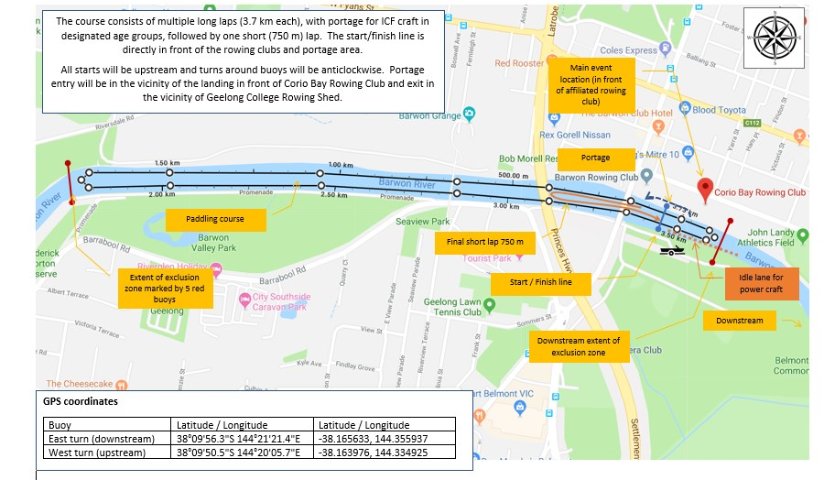

Portage
The portage has a jetty entrance and exit and a flat grass track, approximately 100 metres in length. The Barwon River at this location is non-tidal with minimal current.
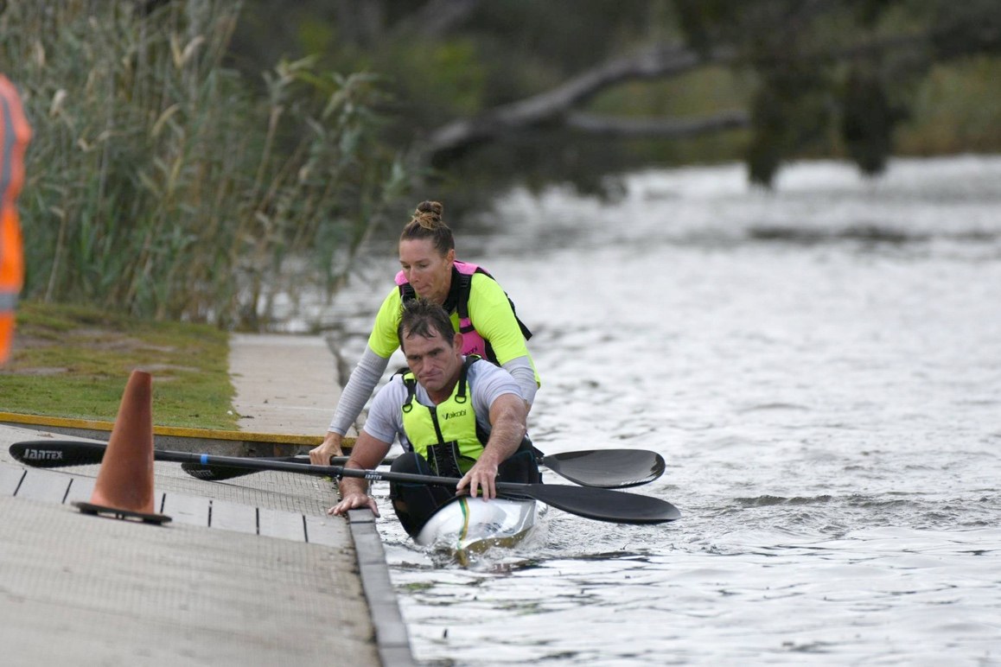
Portage Start

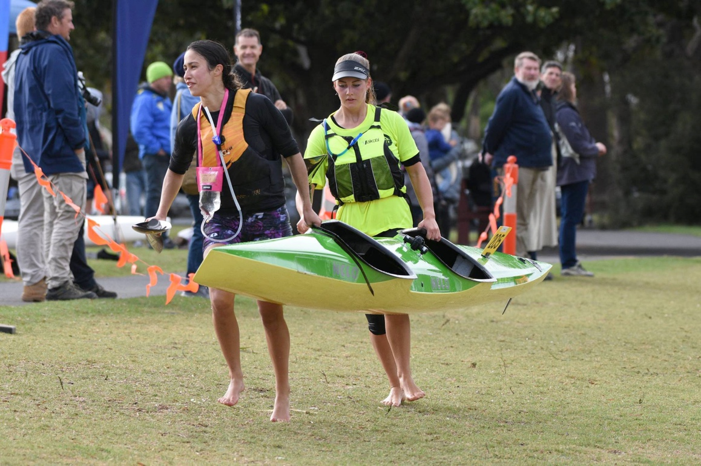
Portage Transition

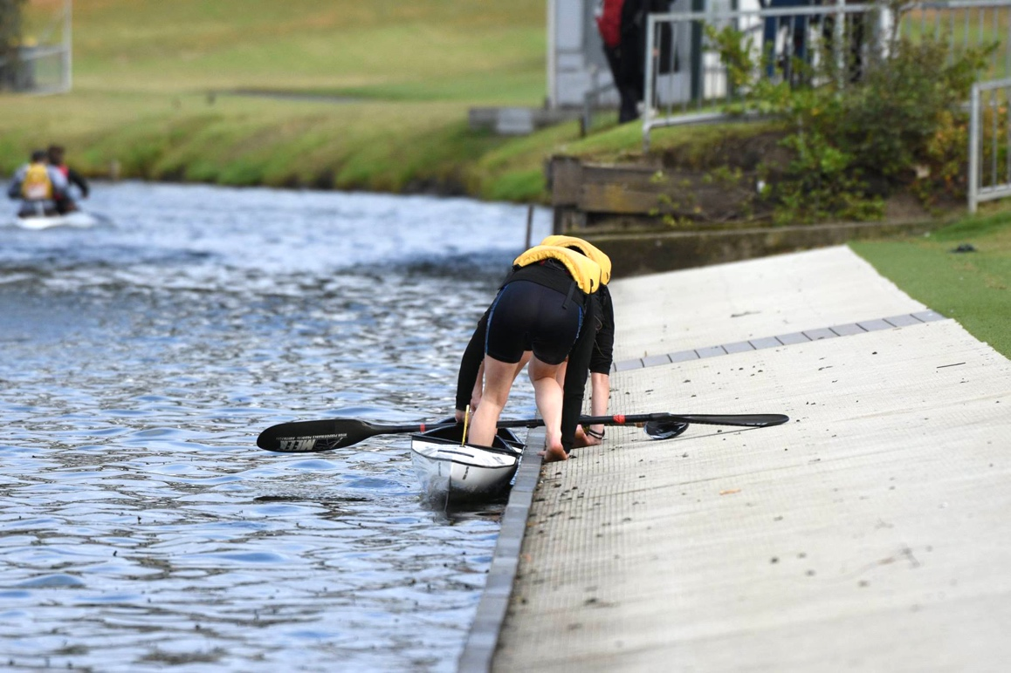
Portage End

Rules
ICF Canoe Marathon Racing Rules – 2019 and
Paddle Australia Canoe Marathon Racing Rules (as revised)

Geelong Weather

Climate averages
Month | Daily  minimum  (°C) | Daily  maximum  (°C) | Number  of days  of rain | Monthly  rainfall  (mm)
April | 9.5 | 20.1 | 11.5 | 48.3
May | 7.6 | 16.9 | 12.9 | 49.5
Statistics provided by BOM for Geelong Airport
(nearest comparable weather site to Geelong)

Safety
An exemption for the wearing of life jackets is being sought however ALL athletes Under 14 MUST wear a proper fitting life jacket.
It is recommended that those who are not strong or confident swimmers should wear a life jacket.
The Competition Committee may direct others to wear a life jacket. The organisers will not have any life jacket’s to loan.
Remember there is no such thing as bad weather, just the wrong clothing. Bring the appropriate clothing for the day.

Medical

Hospitals
University Hospital (Barwon Health), Bellerine St, Geelong
St John of God Hospital, 80 Myers St, Geelong

First Aid
A First Aid station will be available at the venue, Corio Bay Rowing Club

NOTE
The information supplied is known as at the time of publishing and as such may change as the 2020 Paddle Australia Canoe Marathon Championship approaches.

